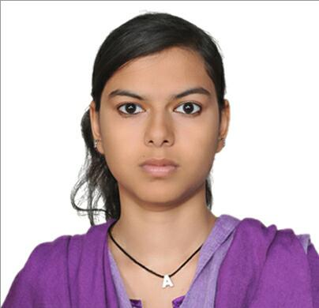
CURRICULUM VITAE
AZRA
AZRA.347751@2freemail.com

CAREER OBJECTIVE

To associate with an esteemed organization in Healthcare that will give me scope to update my knowledge and to be a part of a team that dynamically works towards the growth of organization and gains satisfaction thereof.

QUALIFICATION

Professional Qualification
Pursuing 7th Semester in B.Tech (Biotech.) from Amity University, Noida (India).

Educational Qualification:-
Name of Course | University/Board | Year of passing | Aggregate/CGPA
B.Tech (Biotech) | Amity University, Noida | 2016 (Until 7thsem) | 7.02
AISSCE | C.B.S.E | 2012 | 63.5%
AISSE | C.B.S.E | 2010 | 8.2

TRAINING AND PROJECTS

- Summer Internship Report on “Research on in-captivity of the Arabian Tahr” under guidance of “DR. ANAS IDRIS”, HEAD OF RESEARCH DIVISION, Management of Nature Conservation, ABU DHABI- UAE
DURATION: 25th May, 2016 – 15th June, 2016 (21 Days)

- Seminar report on “GENE THERAPY” under guidance of “DR. NILIMA RAO”, ASSISTANT PROFESSOR, AMITY INSTITUTE OF BIOTECHNOLOGY
DURATION: 01ST FEB’16- 08TH FEB’16 (1 WEEK)

- In-House (Joint In-House and Outhouse) training report On “Practical Training in the field of Biochemistry and Biochemical engineering” under guidance of :-
In-house: “MR. PRABHANSHU KUMAR”, ASSISTANT PROFESSOR, AMITY INSTITUTE OF BIOTECHNOLOGY
DURATION: 8th JUNE 2015 – 12 JULY 2015 (35 DAYS)
Outhouse: “Research on cancer cells using molecular biology techniques” under “Prof. Syed Akhtar Husain”, SENIOR PROFFESOR, JAMIA MILIA ISLAMIAT- NEW DELHI
DURATION: 25th MAY’15 – 8th JUNE’15 (2 WEEKS)

- Term paper on “GENE THERAPY” under guidance of “DR. RACHNA KUMARI”, ASSISTANT PROFESSOR, AMITY INSTITUTE OF BIOTECHNOLOGY
DURATION: 2 MONTHS (MAY-JULY)

LABORATORY TECHNICALS SKILLS

- Familiar with various instruments used in experiments such as autoclave, laminar air flow, centrifugation, magnetic stirrer, incubator, water bath, electrophoresis tank, trans-illuminator, hot air oven etc
- Animal Biotechnology – media preparation, media sterilization, cell culture, cell counting etc.
- Plant Biotechnology – tissue sterilization, plant tissue culture, seed viability testing etc.
- Microbiology – media preparation, sterilization techniques, inoculation etc.
- Cell Biology – Pretreatment, Fixation and Staining of cells, slides preparation of mitotic& meiosis cells
- Molecular Biology& Recombinant DNA technology – gel preparation, electrophoresis
- Immuno-technology – ELISA, WIDAL test, ABO test, SRID and DRID
- Basic Bio computation- Basic Bio computational Skills – BLAST, Clustal omega, ORF FINDER, NEBcutter, Protparam, Multalin etc.

COMPUTER TECHNICALS SKILLS

- Java basics, HTML
- C/C++ language, DBMS.
- MS-Office
- Proficient in using internet.

ASSETS

- Self-Management
- Target Oriented
- Multitasking
- Team Spirit
- Team Building & Team Relation.
- Highly Motivated
- Creative and problem solving

EXTRA-CURRICULAR DETAILS

- Participated in Seminar on “Applications of Radioisotopes & radiation Technology in Industry, Healthcare & agriculture” held on 5th – 6th August, 2016.
- Attended a seminar on “Agricultural Revolution” & “Mycobacterium tuberculosis” held on 1st march,2016 (Science Day)
- Participated in Seminar on “Biotechnology related to waste management” in December 2013.
- Active member of the management club of Amity University of Biotechnology
- Active member of the literary club in writing department of Amity Institute of Biotechnology.
- Winner of Acting-Biology in the Amity Youth Fest 2014
- Participated in debate related to Patents in Biotechnology in the Amity Youth Fest 2014

HOBBIES / INTEREST

- Reading, music, travelling, indoor & outdoor Sports, surfing net related to new researches.

PERSONAL PROFILE

Date of Birth : 17th May 1993

Sex : Female

Marital Status : Single

Nationality : Indian

Languages Known : English, Hindi, Urdu, Arabic & French (BASIC)

DECLARATION

I hereby declare that all the information furnished above is true to the best of my knowledge.

