RESUME
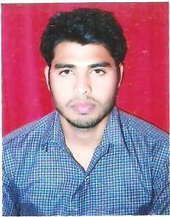
SHAHANAWAZ
Shahanwaz.347813@2freemail.com

CAREER OBJECTIVE :
To Seek a Position, to untilize my skills and abilities for your reputer organization.
EDUCATIONAL QUALIFICATION :
- High School from U.P. Bord, Allahabad
- Intermediate form U.P. Bord, Allahabad
- B.C.A from Punjab Technical University
OTHERE ACTIVITIES & HOBBIES:
- Reading Motivation books, Listening News, Listening Music
- Knowledge of MS Office ,Tally and office work.
PERSONAL PROFILE:
Father ‘s Name : Mr. Aslam Ali
Date of Birth : 06/07/1994
Nationality : Indian
Language Known : English & Hindi
DECLARATION:
I do hereby declare that the above information provided by me is true and fair to the best of my knowledge.
Place :
Date : SHAHANAWAZ

