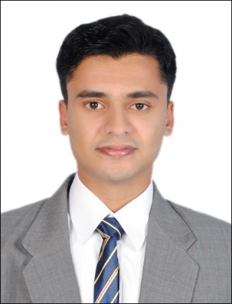
DEEPAK

E-mail ID : Deepak.347821@2freemail.com

Functional Area : Electronics and Communication Engineering.

Professional Experience

Total 2 Years& 7 Months Professional Experience.

- BMS Operator From June 2014 up to date

Presently working as BMS Coordinator with Facility Management for ADNOC (Abu Dhabi National Oil Company) Facility Management, New HQ, Shaikh Khalifa Energy Complex, Abudhabi.

- Marketing Associate From August 2011 to September 2012

Worked as Marketing Associate under Serco BPO Services Limited, Indiafor processing IDBI FEDERAL BANKING services.

- Sr. Process Associate From November 2012 to December 2013

Worked as Sr. Process Associate under Just DialAdvertising Media Services, India.

Educational Qualification

Qualification | College/Institution | Board/University | % | Year of passed
DIPLOMA(ECE) | Tmt. Elizabeth Polytechnic College | Bharathidasan University | 73 | 2009
S.S.L.C | Carmelagiri CMI Public School | CBSE | 60 | 2006

Software Competence:

- Tally

- Post Graduate Diploma in Computer Applications
- Trained in C, C++, Linux, VB, and Oracle 7.

- Trained in MS Office.

- Expert in Building Automation Softwares such as Seimens-Desigo Insight V5.0, Honeywell EBI R410.2,

Trane Chiller plant Manager Tracer Summit and ABB+Voyager lightning Contol software.

Strengths & Skills
- Optimistic, Hardworking person.
- Have good Interpersonal skills.
- Team Worker.
- Sincere.
- Self Confident.

Personal Details:

Date of Birth : 27th Nov 1989.
Sex : Male.
Marital Status : Married.
Nationality : Indian.
Languages Known : English (Read / Write / Speak)
- Malayalam (Read / Write / Speak)
- Tamil (Read / Write / Speak)
- Hindi (Read / Write)

Hobbies:

- Football .
- Playing Cricket .
- Chess.

Declaration:

I hereby declare that the information furnished above is true to the best of myknowledge.

Place: Yours Truly,
Date: (DEEPAK)

