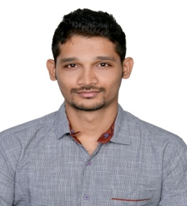
Muthukrishnan
Muthukrishnan.347846@2freemail.com

CAREER OBJECTIVE:

To be integrated with an Innovative, learning and growth oriented organization and to excel as an HR professional by conceptualizing and implementing the best HR practices and developmental activities thereby enabling the organization to achieve its goal and enriching my knowledge and career growth.

PROFILE SUMMARY:
1 Year hands on experience in recruitment, Manpower planning, Training& development, performance management, Employee welfare, Benefits and payroll.

ACADEMICS:
- Master of Arts – Social Work (Human Resources) from Madras University - First Class (2013 -2015)
- Bachelor of Business Administration from Madras University - First Class (2010-2013)

WORK EXPERIENCE:

New vision distributers Private Limited ̴ Retail Industry
Assistant HR – Oct 2015 ̴ Oct 2016

- Responsible for assisting in all stages of the recruitment cycle, responding to enquiries, arranging interviews, completing job offer paperwork.
- Conducting induction training for all new joiners
- Preparation of Manpower report and Monthly HR report
- Maintaining accurate records of all trainings undertaken by members of staff.
- Monitoring sickness and unauthorised leave.
- Knowledge of the standard terms and conditions of employment.

FIELD WORK:
Mega Trust (NGO)– 3 months.
WEDO (NGO)–3 months.
ITC Mangaldeep Agarbatti (Manufacturing Sector)– 3 months.

INTERNSHIP:
Service Sector Internship – M/s. Green Park Hotel – 1Month.
CSR Internship – M/s. Schwing stetter- 1 Month.

STRENGTHS:
- Good Communication and presentation skills.
- Strong motivational skills.
- Good Listener, Thrive in challenges and Enthusiastic.
- Good Team Player.

INTERESTS:
- University Level Badminton Player.

PERSONAL DETAILS:
Fathers name : M. Raghavan
Date of birth : 11th Oct 1990.
Languages known : English and Tamil

DECLARATION:
I hereby declare that the above mentioned statements are true to the best of my knowledge.

