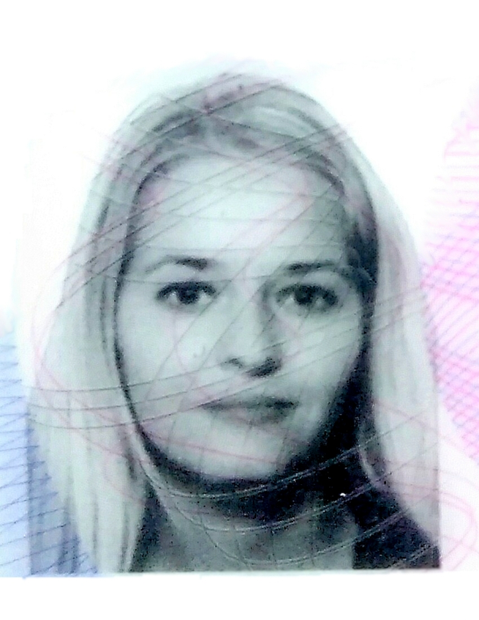

PETRA
Email: petra.347871@2freemail.com

OBJECTIVES

To enhance my personal ability as a person to bring out my efficiency and sense of responsibility towards my career. I assure you that I would confidently carry out my duties and responsibility entrusted to me, in a professional manner and enthusiastic, hard work, flexible, self-discipline and hospitality.

Work Experience

Shop Assistant, Administration, windows dresser
Jan Garabas- Art and Antiques
International Sales of Antiques and Art- Antik (Arts & Crafts)
2002 - 2016
Duties and Responsibilities:

- Email correspondence
- Cashier
- In-charge of our branch
- Purchase of Antiques Marketing
- Internet Sales
- Web Design of company page
- Visual merchandiser
- Windows dresser

PERSONAL INFORMATION:

Birth Date : November 17,1981
Birth Place : Litomerice city,Czech Republic
Gender : Female
Civil Status : Single
Nationality : European
Languages Spoken : English and Czech Language

EDUCATIONAL BACKGROUND:

College: Graphic and Web Designer

Secondary: SOU School of History and Art Profum in Prague

Secondary: Stredni Odborna Skola Umelecko-Prumyslna S.R.O., Podkovarska, 190 00 Prague 9.
(1997-2001) Czech Republic

Primary: 3.Základni škola v Lovosicich (1987-1996)

Abilities: Strong Ability to solve practical problems effectively with internal and external customercommunicative superb proactive attitude to work like to learn new things. I am a well- rounded person I can manage my feelings and motivate myself towards my goals I have the ability to get along with the other people and the ability to fit into the work situation.

Interest:, Interior Design, Art, Fashion, Music, sports, Pc, traveling and getting to know more about Foreign Cultures.

SKILLS:
Expert on Antiques Sales and Purchase.
QUALIFICATIONS:

- 2010 Graphics Worker,MS Office,Windows XP.
- 2010 Web Designer Programming of Web pages.
- 2004 -2006 course of technics of drawing and painting in atelier of Prof.
and Academic painter Jaroslav Klát,in Prague.

I hereby certify that the above information are true and correct to the best of my knowledge and belief.

