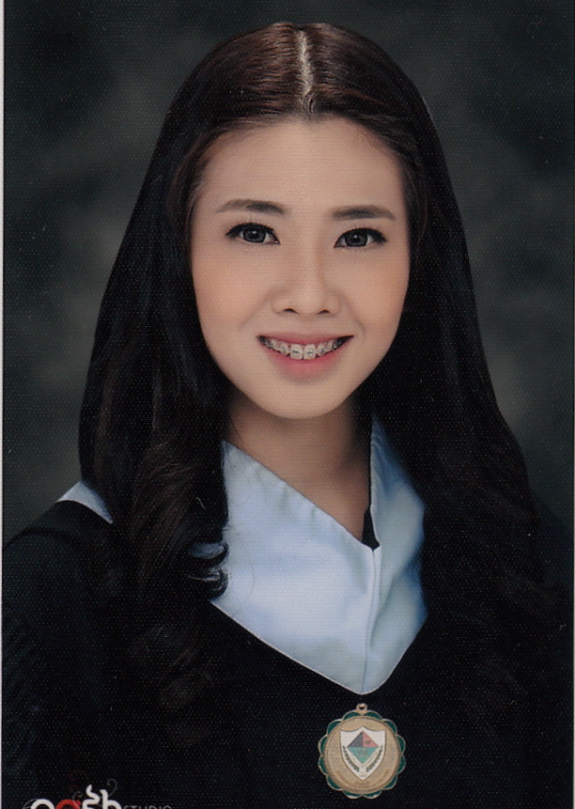

Objective
I would like to attain a challenging job that will enhance my competencies in psychology. I am also aiming to heighten my interpersonal potentials in providing psychological services to people and contribute to the institution’s progress. I would also like to be of help in nurturing people with special needs for their future’s betterment.
- Expected Salary: 5,000 AED
- Notice period: within a month
- Passport Status: Philippine Passport, valid until December 10, 2018
- Visa Status: Residence Visa, under Father’s sponsorship. Valid until April 23, 2017

Experience
CHILD CENTER UAE November 2016- present
- Learning Support Assistant for children with special needs on a school setting. Provided interventions to redirect and decrease maladaptive behaviors, and submitted case reports to the child’s parents as well as to the Senior ABA Therapist to monitor the child’s progress. Attended meetings with the parents and the staff to discuss concerns and suggestions for the betterment of the interventions given to each clients.
- Undergone training for ABA Therapy, and the basics of Shadow Teaching for children with Autism and ADHD.
INDUSTRIAL SETTING INTERNSHIP February 2016-March 2016
- HR Recruitment Intern at Southville International School and Colleges. Administered psychological assessments to job applicants, summarized over time hours and pay rendered by employees, hiring procedures, oriented the newly employed with the school’s rules and regulations, scheduling interviews, notifying applicants through calls and email for initial interviews and teaching demonstrations, pooling of applicants, did recruitment in job fairs, attended to calls and inquiries, posting job ads online, online background checking and reference checking.
CLINICAL SETTING INTERNSHIP January 2016- February 2016
- Worked as a clinical intern at Alabang Psychological Services and Tutorial Center. Administered Psychological Assessments, handled, assisted and taught clients with special needs (Autism Spectrum Disorder, Attention Deficit Hyperactive Disorder), conducted behavioral psychotherapy, and produced clinical case report.
EDUCATIONAL SETTING INTERNSHIP December 2015- January 2016
- Worked as a guidance intern at Holy Rosary Academy, Las Piñas City, handled paper works, counseled students with behavioral and academic problems, produced case reports.

Psychology Society Outreach program December 2014
- Helped facilitate Parenting program at CAA Daycare Center as part of the Psychology Society’s goals
- Facilitated Gift giving for the CAA Daycare Center preschool students last December 2014

Psychology Society Officer- Southville International School and Colleges Chapter September 2014
- President of Psychology Society starting September 2014 till March 2015.
Seminars Attended:
- Tourette’s Syndrome Seminar, 2013
- Industrial Psychology Seminar, September 2015

Qualifications
Professional Qualification:
- Board Exam Passer in the recent Board Licensure Exam for Psychologists and Psychometricians (August 2016) in Manila, Philippines.
- Registered and Licensed Psychometrician, issued by the Professional Regulation Commission (PRC), Philippines.

Academic Qualification:

Bachelors Degree: June 2012- April 2016
- Bachelor of Science in Psychology as Cum Laude with GPA of 3.36.
- Southville International School and Colleges, Las Piñas City, Philippines, April 2016
- Best in Practicum, Best in Thesis, Best in Practicum Portfolio, Outcomes Based Education Awardee
- Mock Board Exam Top Notcher
- Consistent Dean’s Lister from 1st to 4th Year College.
- Served as the Psychology Society’s President in 2014.
- Scored 925/990 in the TOEIC exam last 2013 and September 2015.

High School: September 2008-May 2012
- Graduated as Class Valedictorian at Far Eastern Private School, Sharjah, UAE, 2008
- Consistent 1st Honors since Grade School.
- Served the Student Council as Vice President in High School.

Skills
- Administer, Score and Interpret various Psychological Assessments
- Extensive understanding of the DSM-5
- Comprehension of various psychological disorders
- Conduct Mental Status Examination, Intake Interview, and Job Interviews and Assessment of Applicants
- Recruit and Screen Job Applicants
- Utilize different Selection, Training, Maintenance, and Motivation techniques
- Attending to phone calls, scheduling interviews, meetings, monitoring attendance
- Orientation of applicants and new employees
- Apply techniques in counseling and psychotherapy, and produce clinical case reports.
- Fluent in English.
- Able to read, write and understand basic Arabic and Korean.
- I can also converse and get along well with different kinds of people. I am also fond of children, and always had the heart for people with special needs.
- Knowledgeable with MS Office

