SREELAKSHMI HR ASSISTANT
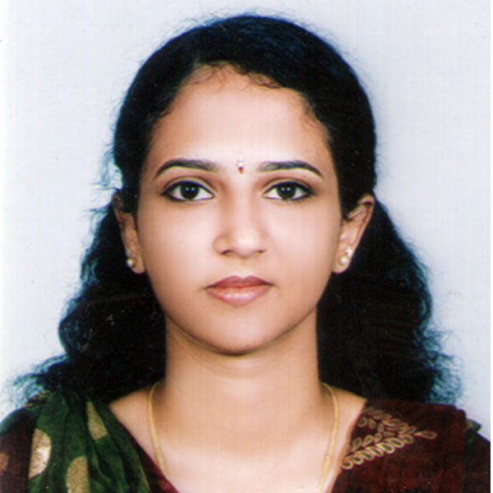
SREELAKSHMI.347932@2freemail.com

Personal Statement:
Human Resources Administrative Assistant with extensive experience in recruiting phone interview, screening and reference checking. Effective organization of candidate qualifications, interview results and outcomes. Capable of not only identifying weaknesses or gaps in existing Human Resource Information Systems (HRIS) but providing recommendations to improve effectiveness and efficiency.

Employment History:

- Human Resources Assistant Cum Front Office - 08 Feb 2016 – 30 Jan 2017
Hercules Super Bazar (Hercules Group) – Thiruvananthapuram, Kerala - INDIA

- Worked with HRIS administrator to create a category for qualified candidates that had been interviewed but not hired. This category became a database from which recruiters could contact individuals who had already expressed a desire to work at Hercules Group and who had interviewed well.
- Assisted in a review of all job descriptions to insure they were up-to-date and realistic.
- Performed pre-interview phone screening calls to enable managers to focus on the most desirable candidates.
- Maintained complete records of all contact with employees.
- Checked the web site daily for resumes submitted electronically.
- Scheduled interviews.
- Involved in payroll management, knowledge of labour laws related to welfare of employees.
- Managed, organized and updated files, records, correspondence, charts and reports – Performed HR office services such as: filing documents, printing reports and documents, stocking of equipment and supplies.
- Handling Phone calls and messages, incoming as well as outgoing.
- Core member to participate in management strategic planning meetings.
- MOM preparation and to send via mail to the MD and other core members.
- Preparation of offer letters, appointment letters, termination letters etc

Academic Qualification:
- Post Graduate Diploma In Human Rights- 2015-2016 (PGDHR- Kerala University)
- Master in Human Resource Management- 2013-2015 (MHRM- Kerala University)
- Diploma In Computer Application - 2013-2014 (C-DIT)
- BSc Biochemistry - 2009-2012 (Kerala University)

Project Details:

- Welfare Activities and Employee Satisfaction: An Impact Analysis at Quilon Co Operative Spinning Mills.
- Worked as Intern In RHOMBUS Software Systems PVT LTD.
- Project done on Plant Derived Anticancer Agents- Department of Biochemistry Govt. College, Kariavattom.

Personal Details:
DATE of BIRTH : 1ST FEBRUARY 1992

