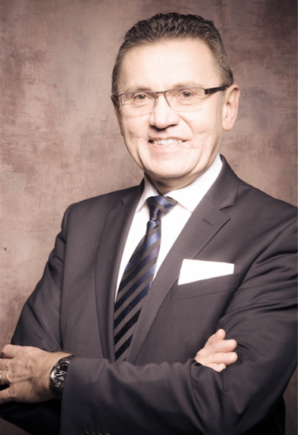

Major steps in career:

2015 Private founder and investor in several start-ups

1998-2014 Mox Telecom AG, founder, shareholder
and managing director (branches in
UAE, USA, Singapore, Vietnam,
South Africa)

1995-1997 RWE Telliance AG, head of department
business development and
new technologies

1993-1995 Scientific Consulting Dr Schulte Hillen,
head of business development
(telco and IT)

1984-1993 Heinrich-Hertz-Institut für
Nachrichtentechnik Berlin,
head of several international research
teams and projects, part of ISO

1983-1984 ETH Zürich, research in electronics
postgraduate studies

Curriculum Vitae

24.12.1958 Born in Bayreuth / Germany

1978 Abitur at Graf-Münster-Gymnasium
in Bayreuth

1978-1983 Study of electronics at university
of Erlangen / Germany (Dipl.-Ing.)

1983-1984 Postgraduate study information
technology at ETH Zurich / Switzerland

1984-1993 Research and project management
in video compression at Heinrich-Hertz-
Institut Berlin / Germany

1992 Promotion to Dr.-Ing. at technical
university Berlin and Hannover /
Germany

Awards

1989 ITG Preis

1991 Rudolf Urtel Preis

2003 Finalist „Entrepreneur des Jahres 2003)

Presentations and Publications

