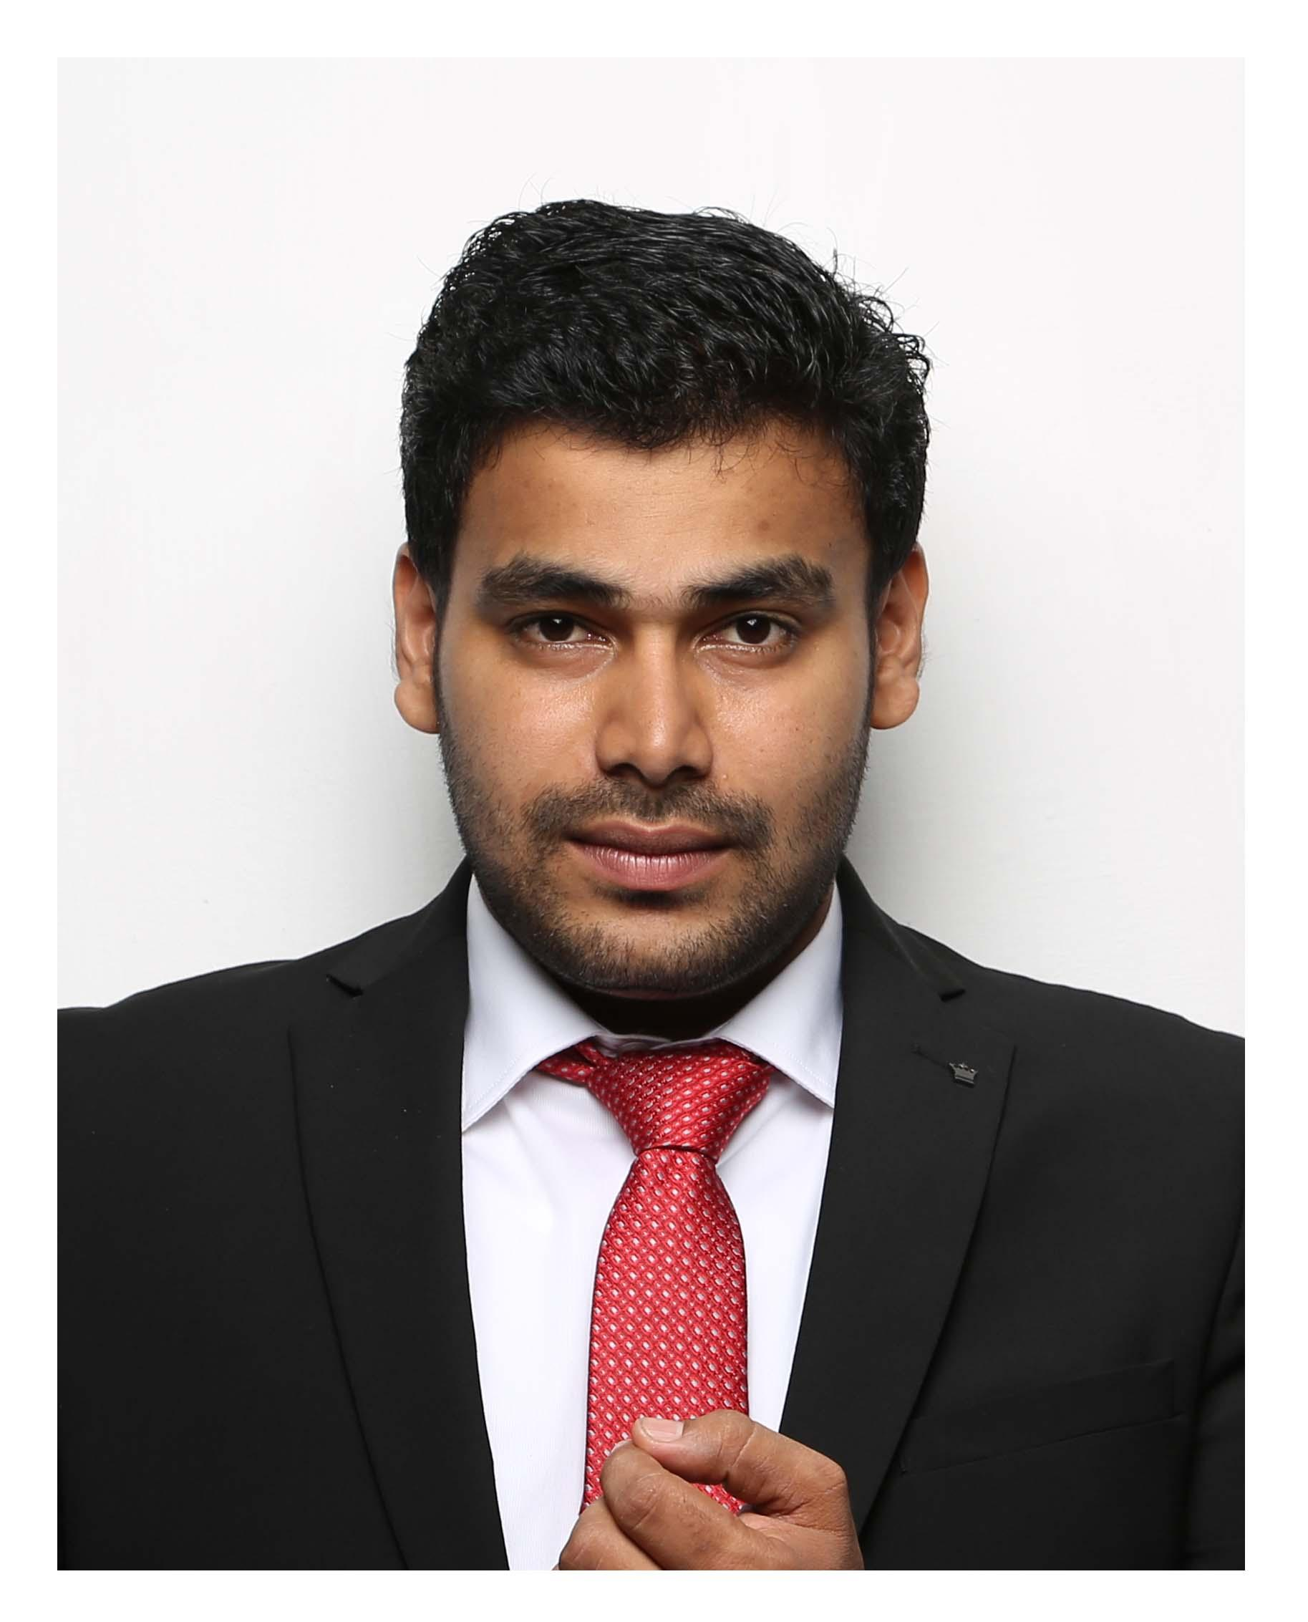

Lijo
Lijo.347970@2freemail.com

Summary
Capable Accountant successful at managing multiple projects and consistently meeting deadlines under pressure. Extensive knowledge of accounting software and processes. Results-oriented Accountant skilled in regulatory reporting, accounting operations and tax accounting. Innovative Accountant proficient in extracting financial data from various reporting systems and suggesting key operational changes.

Highlights

- Analytical reasoning * Account reconciliation expert
- Financial statement analysis * Adobe software proficiency
- Strength in regulatory reporting * Financial planner
- Compliance testing knowledge * Effective time management
- Budget forecasting expertise * Excellent managerial
techniques​
- General ledger accounting * Expert in customer relations​
- Advanced computer proficiency * Flexible team player

Professional Experience

BOSCH SERVICE NEW BOMBAY WORKSHOP Abu Dhabi
Accountant
March-2015- Till
Investigated and resolved discrepancies in monthly bank accounts while under tight deadlines.
Tracked all capital spending against approved capital requests.
Educated management on strategies for minimizing tax liability.
Supplied detailed tax documentation needed to submit accurate corporate returns.
Coordinated fixed asset additions and retirements.

TATA AIG LIFE INSURANCE COMPANY
Cashier
July-2012 To june-2014
- Cash counter management Preparation of daily and monthly reports Custodian of cash Responsible for all the keys to the vaults and lockers Co-ordinate with Head Office Process credit card and check payments Resolve customer complaints in a proactive manner.
- Maintain relationship with the customer Improving procedures to meet and exceed customer expectations.
- Managing account receivables and payables
- provide admin support

AMWAY INDIA - KERALA
Accountant
july-2011-june2012
- Documents financial transactions by entering account information.
- Recommends financial actions by analyzing accounting options.
- Substantiates financial transactions by auditing documents Report to management regarding the finances of establishment.
- Develop, maintain, and analyze budgets, preparing periodic reports that compare budgeted costs to actual costs.
- Establish tables of accounts, and assign entries to proper accounts Sending the Audit reports to the HO on regular basis.
- Prepare and manage purchase orders

Education

2011 B.com
Govt. college Kottayam
2012 Diploma: Photojournalism (4th rank)
School of journalism and visual communication kottayam kerala
2008 Plus two
Co operative college kottayam
2006 Electrician ITI
Z.H.M ITC changanacherry kerala
2004 S.S.L.C
Govt. VHSE Nattakom kottayam kerala

Personal Information
- Place of Birth: Kerala.India
- Date of Birth: 3rd of January, 1987
- Present Resident in Mussafah, Abu dhabi
- Sex: Male
- Status: Married
- Hobbies: Traveling, Reading.

Language proficiency
- English, Hindi, Tamil, Malayalam, Arabic

Interests
Wildlife Photography, Bike riding,

Skills
accounting, Adobe Photoshop, Audit reports, auditing, budgets, credit, Resolve customer complaints, financial, Microsoft Access, Microsoft Excel, Office, Microsoft Outlook Express, Microsoft PowerPoint, windows, Microsoft Word, Operating systems, tables, VISTA

Declaration
I hereby declare that the above-mentioned particulars are true to the best of my knowledge and belief.

