RESUEME
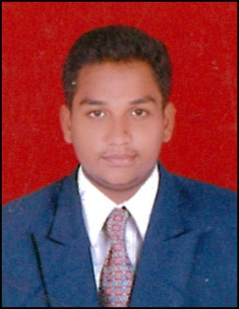
GOUSE
Email: gouse.347977@2freemail.com

Profile:
I am Gouse I completed Bachelor of hotel management and catering technology at Indo American school of tourism in Vishakapatnam, And idone my industrial training at Leela palace Bangalore. And a resident of Kanigiri, Prakasam dist, Andhra Pradesh.
Objectives:
Seeking a dynamic job to get in –depth knowledge of hospitality industry and prepare for future leadership.I would welcome the challenges and develop my skills. Planning to improve my skills and work experience.
EDUCATION QUALIFICATION:
- Completed 3 years Bachelor of hotelmanagement and catering technology from Indo American School of tourism.
- Intermediate from Netaji junior college Kanigiri, Prakasam dist.
- S.S.C from A.V.M high school Kanigiri.
TECHNICAL QUALIFICATION:
- Surfing internet
- Good knowledge about the MS word, excel, PowerPoint.
STRENGETH:
- Mentally strong
- Good communication skills
- Belief my self
- Physically fit and adaptive to new environment and capable to adjust in any situation and able to work for long hours.
HOBBIES:
- My hobbies are playing cricket, bike racing.
- Like to participate debates and paper presentation.
- Listing music and watching television.
- Surfing internet for knowledge as well as entertainment.
DECLERATION:
I hereby state you that above mention particulars are true to the best of my knowledge and belief.

WORK EXPERIENCE:
I Have 2 years of work experience as a waiter Novotel Hyderabad in food&beverage service and currently working in Emirates palace Abudabi.

