Javed | 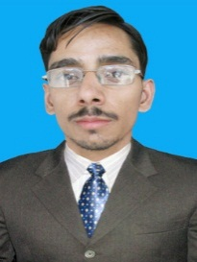  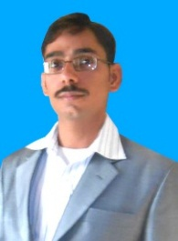  Email: javed.348047@2freemail.com
Skills | - Communication & Presentation Skills.  - Business Innovation & Business Development Planning.  - A productive team player  - MS-Office, Hardware, Software, Windows xp,7 Installation, troubleshooting  - Good command in the following Software  - Inpage, Corel Draw  - Adobe Photoshop, Auto CAD  - Internet surfing, E-Mail  - English Typing speed 40 w.p.m  - Urdu Typing speed 35 w.p.m.
Job Experience | Office Assistant –Cum- Data Entry Operator  Current job  Marie Stopes Sociey (RHF) Project  Current Salary: 25000  3 Year Experience as Office Assistant cum Data Entry Operator in Maries Stopes Society Reproductive Health Franchises Project.  Job Description:  Data Entry, Office Assistant, Monthly Consumption and Supply Reports. Bio Matrix Attendance Report, Manual Attendance, Record of receiving and Sending post Printing, Scanning.  Computer Operator  City Hospital Minchinabad  4 Year Experience as Computer Operator in City Hospital  Job Description:  Data Entry, MS-Office, Hardware, Software, Windows xp, 7 Installation, Inpage, Corel Draw, Photoshop, Auto CAD  Internet, E-Mail  Enumerator  HTSPE (Benazir Income Support Program Survey)  45 days experience as Enumerator (Data Collector) in Field Survey Benazir Income Support Program (HTSPE) Minchinabad.  Job Discription:  Data Colleting, Data Handling, Data Submitting, Meet With people.
Education | Matric-2002  Govt. Model High School Minchinabad  Matric Science,  53% Marks  ICS-2006  Govt. Post Graduate College Bahawalnagar.  Subject ICS-Math, Stat, Computer Science  52% Marks  B.A-2008  Govt. Degree College Minchinabad  Subject B.A, Economics  63% Marks  M.A-2015  IUB Bahawalpur  M.A Islamiat  45% Marks
Professional Qualification | B.Ed-2013  AIOU Islamabad  63% Marks  Diploma of Computer Operator/ Office Assistant  8 Months Diploma from VTI Minchinabad  Auto Cad Operator  3 Month Diploma from NAVTEC Lahore  2D, 3D Drafting

Personal Information | Marital Status: Single  Date of Birth: 16-01-1987

Languages | Proficient in Urdu, Punjabi and English

Reference | Will be furnished on demand.

