Curriculum Vitae

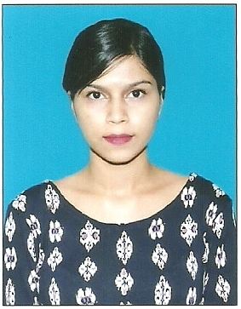
Name : Samantha
Nationality : Indian
Gender : Female
Religion : Roman Catholic
Date of Birth : 2nd January 1996
Languages Known : English, Hindi, and Konkani
Email ID : Samantha.348073@2freemail.com

Career Objective

Seeking a challenging position with an established firm which will be
rewarding, providing a highly motivated, progressive, friendly environment that allows to pursuit the career development which expands my knowledge and skills.

Skills and Attributes

- Mature and confident with an ability to work under pressure
- Self driven and highly motivated with a talent to make things happen.
- Excellent, communication, teamwork, and interpersonal skills.
- Professional attitude and strong commitment to the job.

Education
- SSC Examination-Our Lady of Snow High School ( Goa Board ) (2010-11)
First class (65%)
- HSSC Examination- Carmel Higher Secondary School (Commerce) (Goa Board) (2011-13)
(50%)
- College Degree- Under graduate in B.B.A - Travel & Tourism in Rosary College Navelim- Goa, India.

On the Job Training
Job title | Organization | Department | Duration
Trainee | Club Mahindra-Emerald Palms Varca Goa | Front Office | 4 weeks  (Nov-2015)
Trainee | Jet International Travels & Tours Margao Goa | Cruise Traffic | 6 weeks (April-June 2015)
Trainee | Royal Gala Events | Ground staff | 6 weeks (April-June 2014)

JobExperience:
Worked as Telesales Representative for 3 monthsin Karma Royal Group
Worked as Telesales Representative forNaturaHealth Care for 3 months

Interests and Activities:
Designing, creative art, painting, singing, photography, travelling, internet surfing

