SHAFEED
SHAFEED.348081@2freemail.com 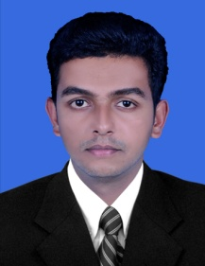

CAREER OBJECTIVE

To make a positive impact in my field of activity leading to Organization growth by creative application of my value based convictions and professional divinity by putting my all efforts in the work assigned to me in the organization where I can grow along with the organization.

EDUCATIONAL QUALIFICATION

- B.B.A (Bachelor of Business Administration)- Specialized in Human Resource -2016
(Calicut University- Kerala, India)

- Higher Secondary Educational Certificate (+2)-2013
(Board of Higher Secondary Education-Kerala, India)

- S.S.L.C-2011
(Secondary School Certificate)

WORK EXPERIENCE

Worked in New Malabar Metals for 3 years as Front office manager.

OTHER SKILLS AND CERTIFICATES

Computer Skills:
- Microsoft XP applications (Word, Excel, Office, PowerPoint, Outlook, Access) – Advanced
- Microsoft Office Document Imaging and Scanning - Advanced
- Acrobat Reader 6.0 – Intermediate
- Photoshop
- SAP sales & distribution (S&D),Business one (B-ONE)
Language Skills:

English : Speak, Write and Read
Hindi : Write and Read
Malayalam : Speak, Write and Read (Mother tongue)

Achievements

- Internship in KELTRON COMPNENT COMPLEX LTD, Kannur, Kerala.
- Completed SAP Training from Beats Education ,Calicut, Kerala.

PERSONAL COMPETENCIES

- Strong Inter-personal organizational skills
- Sincerity towards job and punctuality
- Able to cope under pressure
- Very meticulous and versatile
- Excellent communication skills
- Can work independently or as a part of team

INTERESTS AND ACTIVITIES

- Photography, Football, Cricket, Chess, Internet Browsing.

DECLARATION

I hereby declare that the above furnished details are true and fair to the best of my knowledge and belief. Also I believe that I can build up and conduct a great career with you, thus in turn contributing to the growth and prosperity of the firm that will be beneficial mutually to the organization and me.

