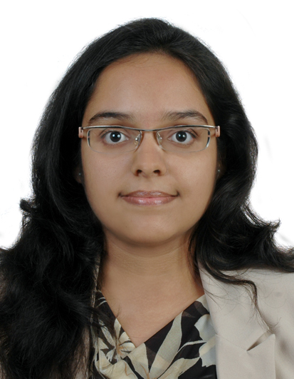
CURRICULAM VITAE
Tanvi

Tanvi.348090@2freemail.com

OBJECTIVE
To cogitate initiative level position wherein I can implement innovative techniques to achieve the expectation of my organization.

TECHNICAL SKILL
Proficient in techniques related to Molecular Biology, Protein purification and estimation, Immunology, Cell Biology, Analytical toxicology, Microscopy (Confocal), Microbiology, Mass Spectrometry, Protein Crystallography (Sample Preparation), Bioinformatics database analysis, Clinical and Diagnostic Tests . Acquainted with the essentials of facilities such as LTQ Orbitrap-Thermo Mass Spectrometer using MudPIT technique and AxioVision Zeiss Confocal Microscope.
Also having good MS Office skills (PowerPoint, Office, Excel) along with superior communicative English.

COMPETENCIES
- Customer Care Executive, Al Borg Medical Laboratories, Abu Dhabi, UAE (14 July 2015 – Till Date).
- Patient inquiry and registration for the requested tests on the LIS (Laboratory Data Management System).
- Assisting in Quality Control analysis by measuring the imprecision for taking necessary corrective action.
- Result follow up and informing critical value to the doctors and troubleshooting pending queries.
- Medical Laboratory Assistant, Bhagyalaxmi Multispeciality Hospital and Research Centre, Nagpur, India (5 July 2012 - 25 February 2015).
- Preparing specimens and running diagnostic lab assays using pipetting techniques.
- Inoculating microbial specimens and microscopic detailing of stained slides.
- Recording and interpreting test results for research statistics..
- Project dissertation in Signal Transduction Laboratory at National Institute of Immunology, New Delhi, India (1 January 2012- 31 May 2012).
- Analyze the biology of Entamoeba histolytica by creating expression systems using cell culture.
- Standardize protocols in sample preparation for immunocytochemistry and mass spectrometry.
- Understand role of EhMAPK kinase in signaling mechanism of E. histolytica.
- Course on Analytical Toxicology – Department of Analytical Toxicology, Amrita Institute of Medical Sciences, Kerala, India (20 September 2011-27 September 2011).
- Identify and characterize adverse effects of chemical compounds.
- Review and assess safety data generated for a specific chemical.
- Experimentation for prevention, diagnosis and treatment of adverse effects.
- Hands on training on ‘Immunotechnology- Immunological techniques’ at Dr. B. Lal Institute of Biotechnology, Jaipur, India (1 June 2009-31 June 2009).
- Exposure to experimental protocols and instrumentation.
- Perform several laboratory diagnostic tests.
- Extraction and separation techniques related to nucleic acids.
- Participated In National Seminar On Biotechnology And Microbiology In Human Welfare- The Indian Scenario, Jaipur, India (23 February 2009 - 27 February 2009).
- Review literature to understand application of biotechnology in microbiology, environment, etc.
- Present Poster on the topological aspects of folding of DNA and protein.
- Gather information from different participants to develop new solutions.

EDUCATION
- Completed M.Sc Biotechnology from Amrita School of Biotechnology Kerala in year 2012 with 8.06 CGPA.
- Completed B.Sc [H] Biotechnology from Modi Institute of Technology Science Rajasthan in year 2010 with 8.695 CGPA.
- Completed Higher Secondary (CBSE) from Indian Islahi Islamic School in year 2007 with 68.2 %.
- Completed Secondary School Examination from Sherwood Academy in year 2005 with 83%.

ACHIEVEMENTS
- Received certificates for participation in National Science Day and Science Olympiads (2007,2009).
- Received certificate for poster presentation on DNA Folding in Molecular Biology in the year (2008).
- Achieved 63rd rank in the National Level Biotechnology Examination (2009)
- Achieved 1St prize for debate conducted on Genetically Modified Crops held on Science Day at Masters
Level (2010).

PERSONAL PROFILE
Date of Birth : 25th January 1990
Sex : Female
Nationality : Indian
Visa Status : Father’s Sponsorship
Marital Status : Single
Languages : English, Arabic, Hindi, German, French, Gujarati, Marathi
Hobbies : Horse riding, lawn tennis, music, travelling, reading

REFERENCES

