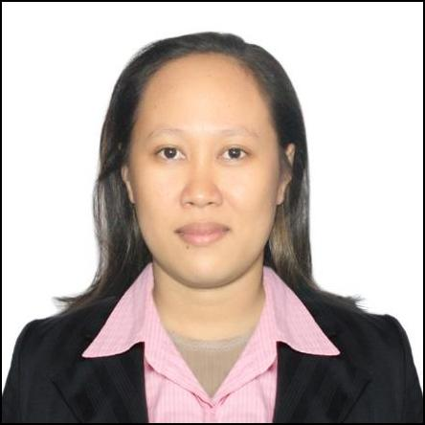
AINOR
AINOR.348110@2freemail.com

PERSONAL INFO.
DATE OF BIRTH | : July 28, 1989
SEX | : Female
RELIGION | : Islam
MARITAL STATUS | : Single
NATIONALITY | : Filipino
LANGUAGE SPOKEN | : English, Tagalog

OBJECTIVE

- To obtain a position that will enable me to use my strong organizational skill, experience, educational background and ability to work well with people.

EDUCATION
COLLEGE | : Bachelor of Art in Islamic Studies Major in History
 | Mindanao State University – Philippines
 | SY 2013-2014
SECONDARY | : Ampatuan National High School
 | AmpatuanMaguindanao – Philippines
 | SY 2006-2007

WORK EXPERIENCE

SECRETARY
SMD MANPOWER SERVICES (Local Employment)

May 15 2014 to Oct. 2016

General Santos City-Philippines

Responsibilities:

- Administers pre-employment proficiency tests for the purpose of ensuring eligibility for employment.

- Answers telephone system for the purpose of screening calls, transferring calls, responding to inquiries and/or taking messages.

- Assists with employment process (e.g. call backs, scheduling interviews, entering information into computer, maintaining current applications, assisting with applicant searches, notification, etc.)

- Assists with new employee orientation (e.g. introducing personnel, payroll, and benefit policies, assisting with enrolment forms, etc.) for the purpose of ensuring employees are knowledgeable of current practices and administrative processes.

- Performs record keeping and clerical functions (e.g. scheduling, copying, faxing, filing, data entry, calculating, verifying, etc.) for the purpose of supporting department staff.

- Prepares weekly payroll for all Town employees and maintains all payroll deductions and distributions.

SECRETARY
COMELEC GSC
January to May 2014

General Santos City-Philippines

Responsibilities:

- Job duties by typing documents, filing, taking inventory and keeping records.

- Also prepare documents, process mail and answer telephones.

- Perform data entry.

LIBRARIAN CLERK
June 2013 to Oct. 2013

Mindanao State University- Philippines

Responsibilities:

- Assisting the student in searching for the books and materials they need in the campus library.
- Handling and issuing them the books they want to borrow.

- Arranging Books in the library.

- Recording the returned materials or the returned books.

COMPUTER SKILL

- Computer Literate (Microsoft Word, Excel, power point, Etc.)

- Knowledgeable in operating office machines like faxes, scanner, copier

I hereby certify that the above information I have given is true and correct to the best of my knowledge and belief.

