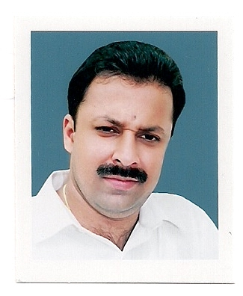CURRICULUM VITAE

VINOD

E-mail: vinod.348149@2freemail.com
_____________________________________________________________________________

Objective
To acquire a position in the sales and marketing industry with the potential for career growth where I can utilize my knowledge and experience.
Personal skills
A highly motivated and organized individual with good communication, presentation and interpersonal skills combined with the ability to build and sustain resourceful work having initiative, willing to work under pressure, high ability to adapt to a new discipline.
Experience in Gulf
Work Experience:

Sales & Marketing Executive (2017January to Till)
Working as a Sales & Marketing Executive in Maxtouch Computers L.L.C, Dubai
M/S: Maxtouch Computers L.L.C is an ICT Solution Company which provides complete solution for ICT and providing AMC for more than 100 Customers in U.A.E
Job Profile:

Liaising with Customer and getting contract and AMC for the CCTV & Network solutions
Providing End to End Solutions to the customers for ICT solutions
Generating Sales Forecast report based on the market demands.

Marketing Officer (2012 April to 2016 May)
Worked as a Marketing Officer in M/S Al Shaqsi Trading L.L.C, Dubai

Company Profile

M/S: Al Shaqsi Trading L.L.C is an Office Automation Company which provides complete solution for Automation from Printers to Fax of CANON Products and providing Maintenance contract for more than 400 Customers in U.A.E.

Job Profile:

Managing and facilitating companies with Office Automation product of Printers, Copiers, Scanners, faxes and AMC.
Selling & Leasing of Canon photocopy machines.
Coordinating and promoting new products of Canon Printing equipment’s in Market.
Liaising with Customer and getting contract and AMC for the Canon Products.
Providing End to End Solutions to the customers for Office Automation.
Generating Sales Forecast report based on the market demands.
Handling customer’s queries, updating of Office Equipment’s at their premises & providing after
Sales service

Sales Executive (2006 November to 2012 March)
Worked as a Sales Executive in M/S Jabal Arafah Trading L.L.C, Dubai
(Leading group of branded office equipments and computer accessories trading)

Job Responsibilities

Meeting clients and selling own personality to move the products
Assisting and managing clients if any changes on orders like non available, short expiry or partial delivery
Closing deals and getting payment on time
Taking orders and arranging deliveries on time
Achieving daily /monthly /yearly targets without any pressure
Retail channel management and well alignment with company policies and schemes from time to time
Action plans for capturing market share from competition
Follow formats / reports provided by the company

Educational Qualification
Bachelor’s Degree in History

Technical Qualification

Diploma in Mechanical Refrigeration & Air Conditioning

Computer Skills:

- Operating Systems: MS DOS, Windows 95/98/2000/XP

- Office Suites: MS Office 97/2000/XP.

Languages Known
English, Hindi, Malayalam & Tamil
Personal Information
Nationality : Indian
Marital Status : Married
Date of Birth : 04-05-1972
Driving License : Holding Valid UAE License

Passport Details
Place of Issue : Dubai
Date of Issue : 19-6-2013
Date of expiry : 18-6-2023
Visa Status : Employment (Transferable)

Thanking you

