APRIL.348164@2freemail.com

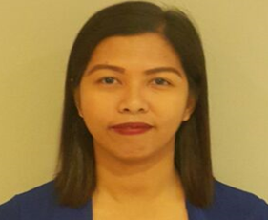
CAREEROBJECTIVE:

To find a position in a successful business establishment where my knowledge, skills, drive, and ability to learn can be articulated and demonstrated and where hard work and contributions are rewarded with the opportunity for advancement

KEY SKILLS ANDABILITIES:
- People and service oriented
- Able to work independently and in a team

MS. APRIL

KNOWLEDGE OF
Costumer service
Cashing up procedures
Up selling
Promoting new product
Report Writing.
- Ability to adjust and cope with changing work condition and situations
- Proficient in MS Office, Applications such as Word, Excel and power point
- Can work on extend hours.
CERDENA

WORKEXPERIENCES:

- Receptionist ACTION HOSPITALITY
October2016 to Saif Zone, Sharjah U.A.E
April 2015

- Waitress HOLIDAY INTERNATIONAL April 2015 to BuhairaCorniche, Sharjah U.A.E
September 2016

- Cash Controller BURGER KING COMPANY September 2012 to Dubai Airport, U.A.E
September 2014

- Document Controller IIEE CompanyOctober 2011 to Manila,PhilippinesAugust 2012

- Costumer ServiceEver Plaza Inc.
September 2011 Manila, Philippines
September 2010

Teacher/Educator Maranatha School June 2008 Quezon City,Philippine March 2010

EDUCATIONALBACKGROUND:

PERSONALDATA:

Birthdate: April 17, 1987
Gender: Female
Civil Status: Single
Nationality: Filipino

Fluent in Speaking and Writing, English and Filipino Language.

Tertiary: National Christian Life College

Bachelor of Elementary Education (B.E.Ed.)

2004-2008

Secondary: Sta. Lucia High School
Manila, Philippines
2000-2004

CHARACTER REFERENCE
Available upon request

