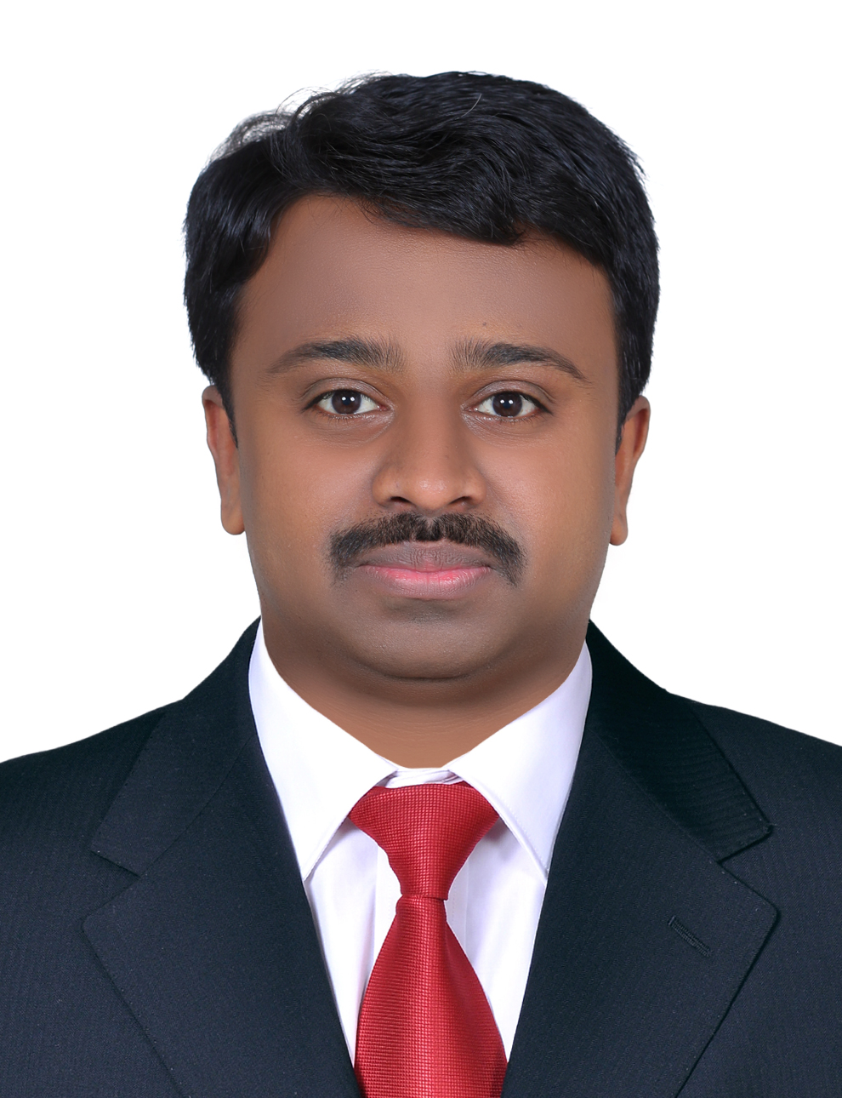 Sanjeev
Sanjeev.348173@2freemail.com

Career Objective:

To be involved in work where I can utilize skill and creatively involved with system that effectively contributes to the growth of organization

Core Competencies:

- Accounts payable & receivables | - General ledger | - Tax Accounting (VAT)
- Financial reporting | - Month and Year end closing | - Auditing
- SAP certified consultant | - ERP implementation & support | - Project management
- Lean, six sigma trained | - ITIL trained | - Technologically Adept
Professional Experience:

- Organization : Samsung SDS (Dubai , Free Zone )
Period : 10th, November 2015 – 22 April, 2016

- Organization : Allianz Cornhill Information Services-A company of Allianz
Period : 16th, April 2012 - September 17, 2015

- Organization: Infosys Limited
Period : March 2011 – April 2012.

- Organization: Franklin Templeton International Services (India) Pvt. Ltd
Period : Jun 15th 2009-Feb 25th, 2011.

Educational Summary:
- Completed MBA in the year 2008 from St. Josephs P.G College, India.
- Completed B.com (Hon’s.) in the year 2006 from Loyola academy, India.
- SAP Certification -SAP-FI (Financial Accounting) from Atos IT Solutions And Services Pvt. Ltd. (2013)
Key Accountability:

- Accounts Payable, invoice processing Vendor management, Payment term, Purchase order creation and approval management, and Vendor management in highly complex Business Environment.
- Accounts Receivable, invoicing, credit management, collection, Customer management in highly complex Business Environment.
- General Ledger accounting, Inter-company transactions Coordination and support in month and year end financial closing activity and reporting.
- VAT tax configuration - Input and output tax and Withholding tax
- Involved in internal and external process audit (Internal Audit) and operational excellence within the organization.
- Expertise in business process improvement, systems design, development and full Life Cycle Rollout/ implementation.
- Six sigma project on facility management and cost reduction in the organization.
- Business process implementation for AGCS Germany in Germany and France- Business travel.
- Excellent business analyst skills with good communication; leverage technical, business and financial acumen to communicate effectively with client, executives and their respective team.
- Proficient in Microsoft Office like MS Excel, MS Outlook and Power Point.
- Certified in SAP FI ( certification from SAP AG, Germany)

Personal Profile:
- Date of Birth : 11th JUN, 1985
- Gender : Male
- Marital Status : Married

