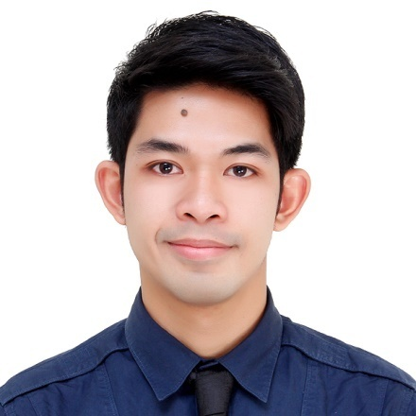
CURRICULUM VITAE

JERAMIL

JERAMIL.348205@2freemail.com

Career Objective

To work hard with full dedication for the achievement of organization objective under satisfying job contact, hence enhancing my skills and knowledge and ready to learn new things.

Qualifications

- Adapts easily to new challenges and shows openness to new ways of doing things.

- Accurate, organize and prioritize my work in a team environment.

- Efficient, fast learner and flexible with the ability to finish task on time and can be work under pressure and with minimal supervision.

- Reliable employee that value work, with integrity, patience and honest.

- A good and productive employee, dependable and self-motivated.

SERVICE RECORD

PROFESSIONAL EXPERIENCE IN PHILIPPINES:

Position :Bank Teller

Company :Quezon Capital Rural Bank, Inc.
LucenaCity, Philippines
August 2011 – May 2016

Duties and Responsibilities :

- Serves as paying and receiving teller (Services the: 1. acceptance of cash and COCI (Checks and Other Cash Items) deposits. 2. withdrawal/encashment of in-house checks. 3. Loan payments and releases. 4. Disbursement of branches. 5. Acceptance of interbranch deposits. 6. Pay-out and send-out of remittances.
- Prepares teller's blotter and proofsheet and files them in chronological order
- Files/reviews all deposit/withdrawal slips received for the day
- Keeps and logs of Cashier's checks and COCI's received for the day
- Keeps and controls hard copies of the daily cash transaction
- Files the signature card
- Assist the Branch Cashier in reviewing documents received from client in the opening of Savings Accounts

Position : Senior Teller / Acting Branch Cashier

Company : Quezon Capital Rural Bank, Inc.
Lucena City, Philippines
June 2016 – January 2017

Duties and Responsibilities :

- Custodian of funds and other securities of the bank.
- Fund to depository banks and Head Office
- Daily monitoring to depository banks.
- Supervise/ monitor teller’s cash operation and transaction
- Approves transaction and reports and sign documents within authority
- Keeps and controls accountable forms and office supplies, furniture, fixtures and equipment.
- Supervises funding for Current Account operations and handle inward or outward checks
- Attend to bills to be paid
- Supervises online and offline fund transfer to/from Branches and Head Office
- Handles petty cash fund
- Process pay-out and send-out remittances of clients
- Process the trading of Foreign Exchange transactions
- Member Branch Loan Committee in processing of loan application before submission to Loans Department

ACADEMIC RECORD

Tertiary : Southern Luzon State University
Lucban, Quezon, Philippines
Bachelor of Science in Business Administration
Major in Marketing Management
2007-2011

Secondary : Liliw National High School
Liliw, Laguna, Philippines
2003-2007

Elementary : Liliw Elementary School
Liliw, Laguna, Philippines
1997-2003
COMPUTER PROGRAMS / SOFTWARE OPERATED

- MS Office
- Windows
- CASA Banking System

PERSONAL DATA

Date of Birth : November 4, 1990
Place of Birth : Sta. Cruz, Laguna, Philippines
Civil Status : Single
Sex : Male
Height : 162 cm.
Weight : 120 lbs.
Religion : Roman Catholic
Visa Status : TouristVisato be expired on May 16, 2017

