A B R A R
ABRAR.348246@2FREEMAIL.COM

M a r k e t i n g E n t h u s i a s t

Quote of Life: "Be like a diamond precious and rare,don't be like stones which are found everywhere"

C A R E E R

O B J E C T I V E

To carve out a platform for myself in the corporate world aligned to the marketing/operations domain in an organisation wherein I can prove my abilities and talent contributing towards the organisational and personal growth in parallel. With entrepreneurial instinct always willing to take high level initiates and can do multi-tasking.

E D U C A T I O N

PGDM-Post Graduata Diploma In

Management (Major in Marketing)

2014-2016

Marks/Grade: A

Bcom.-Bachelor Degree in Commerce

2011-2013

Marks/Grade: 80.14%

HSC: (Major In Commerce)2008-10

Marks/Grade: 78.50%

SKILLS
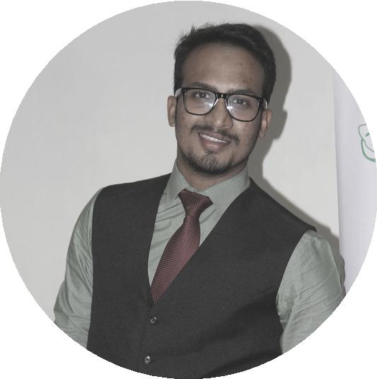

RESEARCH

COMMUNICATION

TEAM PLAYER

ADAPTABILITY

ABILITY TO WORK UNDER PRESSURE

TEAM HANDLING

QUICK LEARNER

CREATIVITY
E X P E R I E N C E

E X P E R T I S E

MARKETING

CHANNEL MANAGEMENT

BUSINESS DEVELOPMENT

OPERATIONS

CAMPAIGN PLANNING

KEY ACCOUNTS MANAGEMENT

T E R R I T O R Y M A N A G E R

New Client Acquisition-Making pipe-line of prospects,sending quotations,negotiations,follow ups,conversions

Campaign Planning-Devise sound and effective marketing campaigns for the company's tea & coffee vending machines.

Channel Management-Partnering and nurturing right set of distributors in the assigned territory and accordingly drive business via primary and secondary sales

Customer Relationship Management-Taking regular feedback from existing clients,resolve escalations if any and maintaining a long term relationship with them.Also increasing business out of them.

COFFEE DAY GLOBAL LTD (VENDING DIVISION)

MUMBAI

2016-17

C O R P O R A T E M A N A G E R - ( C O R E T E A M )

Team Management: At Box8 was handling a team of 23 employees comprising of Store managers,ground staff,operations executives and delivery boys.Nurtured the employees in order to help them work efficiently

Operations management: Managed the day to day operations of the corporate dine in stores and ensured order deliveries on time

Marketing Mix: Devised effective go to market plans to ensure maximum customers reach and help increase the sales.Did corporate events,corporate tie-ups in order to vouch upon all customer touch points so far as corporate were concerned.

Customer grievance handling : Focused on zero customer complaints.If any, investigated the concern deeply and accordingly resolved the customers complaints.Thus, ensured customer satisfaction & retention.

A C C O U N T S E X E C U T I V E

Book Keeping& Vendor payments: Maintaining records of all the bills project wise for the accounting year and accordingly help the manager in preparing books of accounts and reconciliation statements.
Disbursement of vendor payments after processing the bills in the ERP system. Ensure proper tax deductions

BOX8

(QSR CHAIN)

MUMBAI

2015-2016

TATA PROJECTS

LTD.

MUMBAI

2013-14

A W A R D S & R E C O G N I T I O N

Awarded with the Title of 'Best Student Of the College' for two consecutive years during graduation -2012 & 2013 Have won Several prizes at intercollegiate competitions in elocution, debate, singing, dancing, acting, drawing, etc Volunteered The BMA awards wherein many top notch personalities of banking, ecommerce and FMCG industry were the members of the panel.
Awarded with the prize for Best Overall performance during HSC.

S U M M E R I N T E R N S H I P & I N D U S T R Y I M M E R S I O N P R O J E C T

Project Title: study of customer management cycle

Learnings: The comparative study helped me devise strategies for customer acquisition for a start-up.
Conclusion: Understanding the customer from the grass root level is essential for survival of any business.

Industry immersion project-“Study of E-commerce (online retail) industry in India”.

The project helped me understand the e-commerce business focused to online retail in the country. Studied the several facets of the online retail business by understanding the business models of e-commerce giants
Evaluating several factors that drive the growth of the e-tail sector and conclusion that Omni-channel being the strategy to survive in the cutthroat competition in the country’s retail space.

MEDIKABAZAR.COM MUMBAI

2015

(3 MONTHS)

E X T R A - C U R R I C U L A R A C T I V I T I E S

- Singing enthusiast - participated in singing competition in various cultural events including the College Fest in Feb’15.
Member of the cultural committee, a student driven club that plans and conducts various cultural programmes in the college.
Successfully organised cultural events, competitions including the Cultural Fest in Feb’15 at

KBS

Had been Joint secretary of the college during graduation.

P E R S O N A L D E T A I L S

Father’s name: Shamshuddin Ali Parkar

languages Known:

English,Marathi,Hindi-(Can write,read & speak Fluently)

Urdu-(can speak and read)

Hobbies:

Reading

singing

cooking

playing cricket

Social Networking

Marital status: Single

