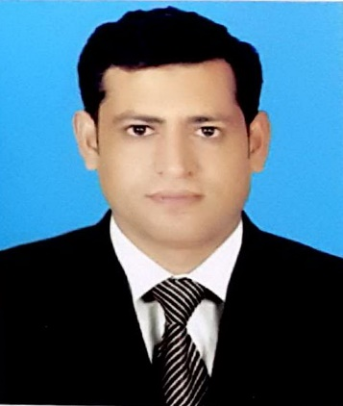

Ghulam
ACCOUNTS & FINANCE
PROFESSIONAL

Ghulam.348261@2freemail.com

PROFESSIONAL SUMMARY
An accounts and finance professional with MBA degree and 8 years’ experience under his belt; having hands on experience of all leading tools and adept to work with multiple teams of varying backgrounds to deliver the optimum results.

EDUCATION

MBA (Banking and Finance)
Hailey College of Banking & Finance, University of the Punjab, Pakistan 2012 - 2016

B.COM (IT)
University of the Punjab, Pakistan 2004-2006

PROFESSIONAL EXPERIENCE

Travel 92 (Pvt) Ltd
Senior Accountant

Reconcile bank statements & maintain liaison with banks.
Verifying, allocating, posting and reconciling accounts payable and receivable MIS reporting to Financial Manager
Analysis & reporting of financial data & financial statements Managing company ledgers & verify daily reports
Assist with annual budget preparation as required
Prepare journal entries & analysis of accounts as required Assist with payroll administration
Management of petty cash transactions
Prepare periodic & ad-hoc management information reports as requested Processing & recording business expenses & office expenditures

Union Enterprises

Finance Officer cum Accountant

PROFESSIONAL SKILLS
ERP
MS Office

PERSONAL SKILLS
Interpersonal Communications Adaptability Critical Thinking Teamwork Fast Learner

Area of interest Accounts & Finance Administration Management
Implement financial policies & budgets; Maintain cash control
Establish, maintain & reconcile the general ledger Process supplier’s invoices
Ensure security for all credit cards and verify charges
Assist with annual audit
Reporting to Manager
Ensure transactions are properly recorded & entered into computerized accounting system.
Prepare & reconcile bank statements

CERTIFICATIONS & MISCELLANEOUS
      - I got a certificate of Associated Public Accountant (Inter) from Pakistan institute of Public Finance and Accountant with one paper left from Final Stage to complete the APA
      - I got Certificate of Computer Sciences from Waris Computer College Lahore with Microsoft office Package, a three month short course which included (Microsoft Excel, World, Power Point)

