Hafiz
Hafiz.348266@2freemail.com 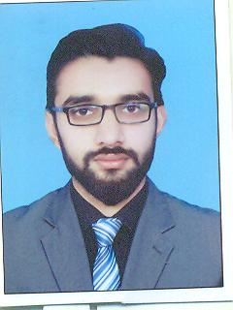

PROFILE

OBJECTIVE
Seeking a challenge opportunities to demonstrate my skills, abilities and excellent marketing acumen to attain experience and knowledge in an organization working on a global scale offering scope for career growth and professional Development.

KEY COMPETENCIES
- Flexible Attitude
- Self-Motivated, Dedicated, Honest and Hard Working.
- Ability to work under High-Pressurized Work Environment.
- Quick Learner

PROFESSIONAL EXPERIENCE

Oxenlab Software House
Location: 57-H Gulberg 3, Lahore, Pakistan

Web Developer August-2016 to November-2016

JOB DESCRIPTION

- Go through basic concepts of OOP and apply them into different examples.
- Working on basic concepts of PHP.
- Get all the knowledge about LARAVEL framework. Laravel hierarchy, style of code and knowing that how to use it.
- I am working as a backend coder.
- SQL connectivity and using it with Laravel.
- Develop some web menus like, login, CRUD operations on student record and working with team to develop a Quiz Portal website.

EDUCATIONAL BACKGROUND

BS (Hons) in Computer Science 2012-2016
Superior University, Raiwind road, Lahore

Intermediate in Computer Science (ICS) 2009-2012
Government Shalimar college, Lahore

Matric in Science 2007-2009
Government High School, Lahore

COMPUTER SKILLS

- Microsoft Office (Word, Excel, PowerPoint).
- Internet.
- OOP
- C#, ASP.NET
- SQL Management
- HTML
- CSS
- PHP
- Laravel

Awards
- Best Teaching assistant at Superior University, Lahore (2012)
- Batch representative (CR) in Superior University (2012-2016)

Language Proficiencies

English: Speaking: Fluent,
Reading: Excellent,
Writing: Excellent.
Urdu: Excellent in speaking, reading & writing.
Punjabi: Excellent in speaking, reading & writing.

References

- Can be furnished upon request

