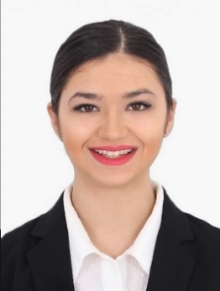
Ivana
Ivana.348272@2freemail.com
Work experience:
Ecco brand Dubai, UAE Aug.2016-to present
Senior Sales consultant
- Meets with customers in a sales environment to drive product sales and knowledge
- Follows up with any clients to make sure that they are satisfied with product
- Help improve brand awareness in cooperation with the marketing department
- Responsible for working in a target driven sales environment to maximize the opportunity of sales
- Maintain high standards of Visual Merchandising housekeeping in term of cleanness, display and stock rotation

Mendoza Restaurant, Stade, Germany Jan. 2016 – to Jun. 2016
Guest relation officer

- Coordinating and multi-tasking job duties in a busy environment
- Providing excellent customer service
- Handling guest complaints and concerns in an efficient and timely manner
- Build and maintain guest experience standards in order to build strong loyalty
- Examine activities logbook, assign tasks appropriately and implement control schedule daily

Hotel and restaurant “Sumski feneri” , Bitola Macedonia Sep. 2014- Dec. 2015
Guest relation representative

- Provide customers with information on daily deals and promotions
- Discuss and build trust productive and lasting relationships with guests
- Communicate with customers to assess and satisfy their needs, and meet or exceed their expectations
- Analyzing customer feedback and providing strategic direction to continuously improve overall rating

Education:
- S.O.U. Taki Daskalo bussines school and college (2010-2014)
- Goce Delcev elementary school (2002-2010)

- Trainings:
- “Journalism and entrepreneurship “ –Turkey,Akcakoca Mar.2016
- “This is my right” – France,Loisy Aug.2015

- “Europe in good shape” – Bulgaria,Berkovitsa Nov.2014

- “Leadership and public speaking” – Macedonia, Ohrid Oct.2014

Excellent command of Microsoft office tools, POS, WordPress, CRM software
Languages:
- Macedonian (native)
- English -fluent

- Croatian- fluent
- Serbian- fluent
- Russian – intermediate
- German- basic

