RESUME
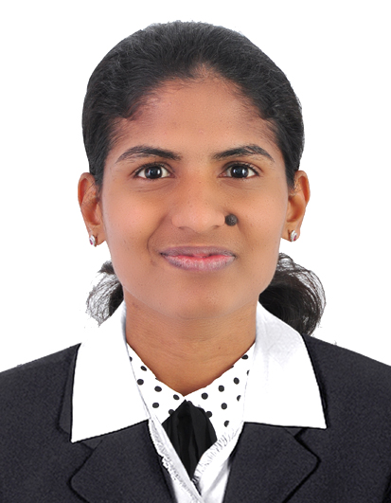
SHRUTHI

SHRUTHI.348297@2freemail.com

OBJECTIVE:

Intend to build a career that helps me grow professionally while being resourceful, innovative and flexible. Seeking a role which will help me to explore and realize my potential to the maximum.

EDUCATIONAL QUALIFICATION:

COURSE | UNIVERSITY | INSTITUTE | BATCH | %OBTAINED
BE(CSE) | Visvesvaraya  Technological University,  Karnataka | City Engineering College,  Bangalore(upto7thsem) | 2011-2015 | 62.22%
PUC | Department of Pre-University Education,  Karnataka | S.V.P U College  Gangolli, KundapurTq | 2011 | 58.83%
SSLC | Karnataka Secondary Education Examination Board, Karnataka | S.V.English Medium High School GangolliKundapurTq. | 2009 | 76%

TECHNICAL SKILLS:

Skills | Ms word, Excel, power point,Concepts of Java and html, Basic concepts of web, DBMS
Platforms worked on | Windows XP/7,Ubuntu

PROJECT IN COMPANY:Project in ISRO ISAC(ISRO Satellite Center) Bangalore.

DESIGNATION:ProjectTrainee (from JAN 12th to APR 30th 2015 )

ABOUT THE PROJECT: ETHERNET BASED COMMUNICATION WITH FPGA BOARD.

- USB and TCP/IP Communication with FPGA board.
- Transmission of data from FPGA board to PC via LAN and USB based Protocols.
- Understanding of vhdl code for configuring LAN port on the FPGA board.
- Writing a java based client server program to read and write data to and from the FPGA.

CERTIFICATIONS:
- Certified by ISRO ISAC Bangalore for project ETHERNET BASED COMMUNICATION WITH FPGA BOARD

EXPERIENCE:
From July 2015 to Jan 2017
Mphasis (Mangalore, Karnataka)
Worked as Admin/ Secretary
Resposibilities:
- Word processing, creating presentations, and data entry.
- Record maintaining.
- Arranging meetings and appointments.
- Responding for telephone calls.
- Receiving and directing visitors.
- Internet searches.
- Communicating with people, who are coming to office and fulfilling their requirements.
- Worked for reception if needed.
- Good customer service

STRENGTHS:

- Can work comfortably either in a group or individually in any location & strategies.
- Interest to take initiative and motivate others and self.
- Interested to learn new things.

DECLARATION:
I hereby declare that information furnished above is true to the best of my knowledge.

