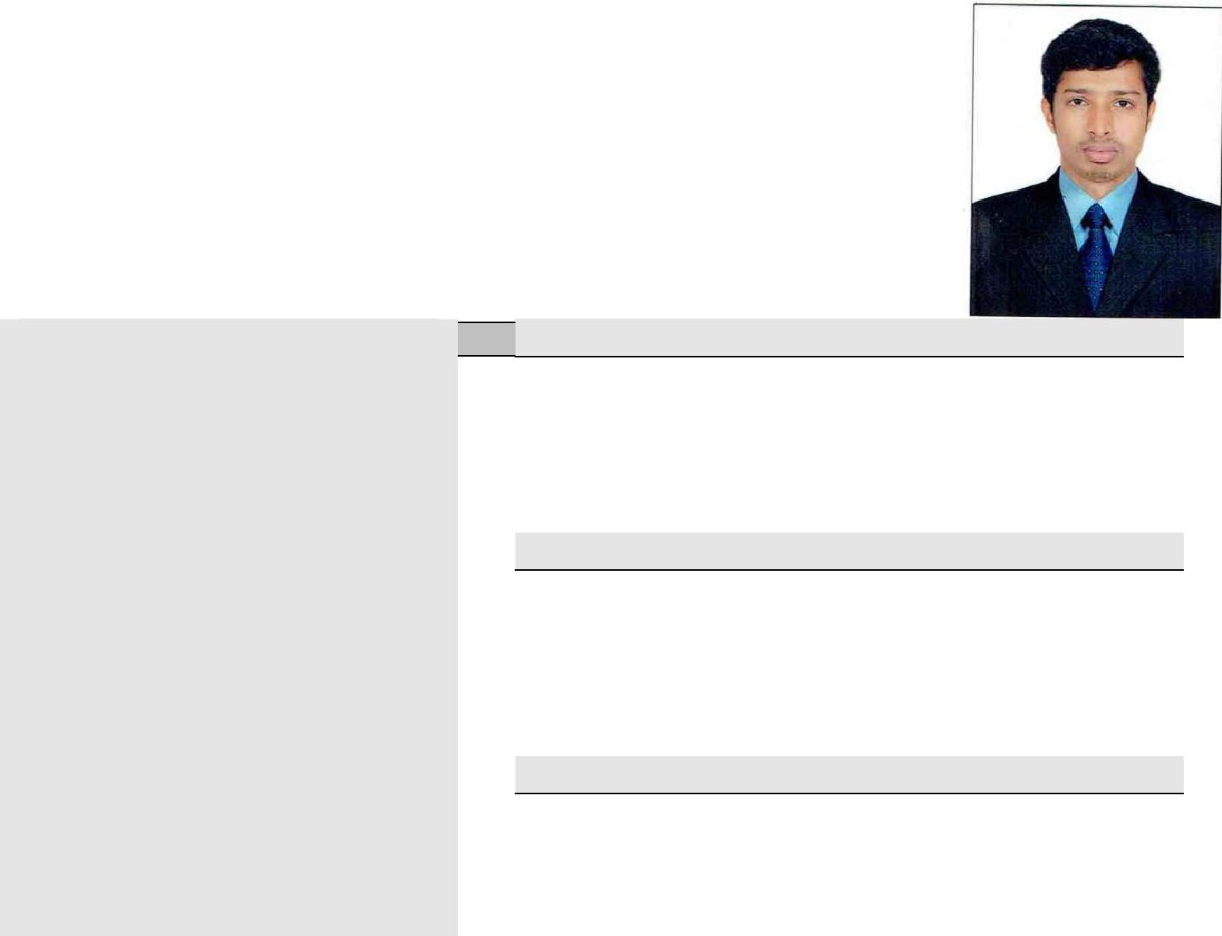CURRICULUM VITAE

KISHORE
KISHORE.348325@2freemail.com

Objective

A highly enthusiastic environmentalist with experience in environmental field looking for a position of environmentalist to utilize my knowledge and experience

Strengths

- Confidence, Dedication, Hardworking.

- Eager to work in a competitive environment

- Leadership quality

- Self-confident

Area of interest

Administrator, document controller, Research and development,Office work, laboratory.

Academic Details:
 |  |  |  |  | Year of |  | Class
Class/Course | Name of Institute |  | Board/University |  |  |  | Obtained
 |  |  |  |  | Passing
 |  |  |  |  |  |  | (CGPA)
MSc | Department of
 |  |  | Manipal University |  | 2013
(Physics) | Science, Manipal
 |  |  |  |  |  |  | Distinction
BSc | Millagres College,
 |  |  | Mangalore University |  | 2011 |  | Distinction
(PCM) | Kallianpur

Computer Proficiency:

- MS Word, MS Excel, MS DOS, Power Point, Internet Applications, Corel draw.

Extracurricular Activity:

- Participated and exhibited the model entitled “Biomedical Waste Management” in the Department of

- Environmental Science, Kuvempu University.

- Has attended and actively participated in the Environmental Awareness Programs held at Nittur Village, Hosanagara.
- Honours Course in Rain Water Harvesting.

- Certificate Course in Communication skills.

Research Experience

Name of the Organization : Kuvempu University,Shankaraghatta

Designation : Major Research Project Fellow

Period : 1year

Project Title : “Degradation and Removal of basic dyes by Electrochemical

Method with reference to pulp and paper industry”.

Objectives of the project is

- Collection of dyes and effluents from paper and pulp industry.

- Development electrochemical techniques for the degradation of dyes and effluents using different electrodes.

- Analysis of TOC and COD values of dye samples and effluents before and after the electrochemical treatment.

- Evaluating the optical density of dye samples and effluents at λ_{max} through UV-Vis studies before and after the electrochemical treatment

- Evaluating the mass reduction of dye samples and effluents through LC-MS studies after electrochemical treatment.

- Optimization of experimental procedure for the treatment of dyes and effluents

- Scaling-up of the procedure for large-scale effluent treatment

Work experience

- Documentation Controller (Modern Bakery L.L.C, UAE – from 2014 to till date )
- Administrator cum Documentationcontroller(Manipal Group PVT, India – from 2013 to 2014 )
Duties & Responsibilities as Documentation controller
- Makes sure that controlled copies of latest approved documents and drawings are given to the appropriate staff, subcontractors and suppliers as applicable
- Generate the various document control reports as required.
- Coordinate all activities related to the Document Control procedure, including technical documents, drawings, and commercial correspondence.
- Input document data into the standard registers ensuring that the information is accurate and up to date.
- Maintain updated records of all approved documents and drawings and their distribution clearly
- Maintain the files and control logs as required by the project.
- Maintain the documents and drawings in the Document Control office under safe custody without any damage or deterioration with easy traceability.
- Strong problem-solving and communication skills demonstrated in successful resolution of customer billing issues.
- Recognized as a dedicated worker who is driven to meet accounts receivable targets and contribute to the company's profitability
- Receive and verify invoices and requisitions for goods and services
- Verify that transactions comply with financial policies and procedures
- Prepare, verify, and process invoices and coding payment documents
- Prepare batches of invoices for data entry
- Data enter invoices for payment
- Maintain updated vendor files and file numbers
- Providing sales and administrative support involving efficient handling of top and confidential agreements.
- Updating the status of sales order in the database or computer.
- Daily supervision, coordination and direction of all Colleagues
- Maintaining high staff morale and team spirit within the department
- Leading and coaching all Colleagues
- Involvement in recruiting, staffing and scheduling ensuring adequate staffing levels to satisfy guest needs

Personal Details:

Date of Birth : 22-02-1991
Sex : Male

Nationality : Indian

Declaration:

I hereby declare that the above written particulars are true to the best of my Knowledge and belief.

