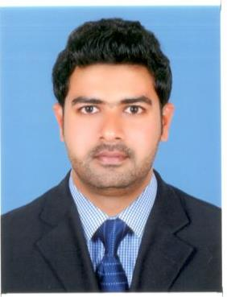

ABDUL

ABDUL.348372@2freemail.com

OPTOMETRIST (BSc, DOA)
Dubai Health Authority
Supreme Council of Health, Qatar

PERSONAL DETAILS

Date of Birth: 11 May 1987

Sex : Male

Marital Status:Married

Nationality : Indian

LANGUAGES KNOWN

English, Arabic, Hindi &Malayalam
OBJECTIVE

To work in a professional and competitive environment that best develops my talents and provides opportunities for learning from mentors and facilitates personal growth and creativity.

SUMMARY

An exceptional professional who has over six years of experience in optometry; the ability to improve visual standards of patients; with excellent time management skills; proficient in computer skills; excellent organizational skills.

ACADEMIC QUALIFICATIONS
Plus Two (Science): Government of Kerala -2005
S.S.L.C: Government of Kerala- 2003

PROFESSIONAL QUALIFICATIONS

Bachelor of Science in Optometry

Certificate Issued by Board of Examinations, (2009-2011)
Techno Global University, Shillong, Meghalaya, India 793003

Diploma In Ophthalmic Assistance (DOA)

National Eye Hospital, Kozhikode, Kerala, India (2006-2008)

Certificate Issued By Board of Examinations, Directorate of Medical Education, Govt. of Kerala, India

LICENSES/ASSOCIATIONS
- Dubai Health Authority DHA-
- Supreme Council Of Health -1986, State of Qatar
- Indian Optometrists Association (Kerala Chapter)

EXPERIENCE RECORD

Period : 27/May/2015 to till date

Position : Optometrist

Executive Optics
Union COOP, Al-Qusais, Dubai, UAE

Period : 01/May/2014 to 20/May/2015

Position : Optometrist

IRIS OPTICS
Bengachery complex TB road junction, Kanhangad
Kasaragode 671315 Kerala India

Period : 15-Oct-2010 to 14-Dec-2013

Position : Optometrist

Al Dar Optics

Lulu Hyper Market, Garrafa,PB No: 35301

Doha, Qatar

Period : 20-Mar-2008to 28-Sep-2010

Position : Optometrist

Vasan Eye Care Hospital

NethraBuilding,

Near SBI Bank, Fort Road

Kannur – 670001,Kerala, India

RESPONSIBILITIES

- Communicating with patients to get detailed case histories.
- Executed vision screening, depth and color perception to estimate patient vision, prevalence of eye disease and vision disorders.
- Executed preliminary examinations of patients for diagnostic procedures like A-scan, Perimetry, corneal topography, pachymetry, specular microscopy and contact lens assessments.
- Corrected vision defects of patients by prescribing prescription glasses and contact lenses under proper clinical protocol and informed patients of their conditions and referred them to ophthalmologists if disorders or diseases are detected.
- Advised the necessary information to help improve visual standards to the patients
- Recorded proper case details as per the clinical protocol.
- Maintained and utilized equipments and accessories under possession with utmost care and assisted doctors on call.
- Assisted all specialty clinics in rotation.
- Participated in outreach programs and academic events

DECLARATION

I, ABDUL, hereby declare that all the in formations furnished above are correct and true to the best of my knowledge and belief.

