THAHASIN  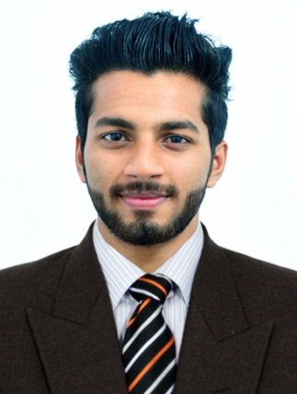  THAHASIN.348419@2freemail.com  Personal Profile  Date of Birth : 22/01/1995  Age : 22  Gender : Male  Nationality : Indian  Marital Status : Single  Languages : English, Hindi  & Malayalam.  Hobbies : Badminton,  Cricket.  Area of Interest  ACCOUNTS  ADMINISTRATION  SALES.  Interpersonal Skills:  Good Command over Calculation  Leadership  Loyal Towards Work & Duties  Positive Attitude  Excellent Team Player | CAREER OBJECTIVE:  To Achieve a Position in the Professional Field that will Enable me to Prove My Ability, Managerial and Interpersonal Skills Together with My Ability to Quickly Acquire and Hone new Skills so as to Provide Opportunity for further Growth and Advancement to the Organization and Self.  ACADEMICA CREDENTIALS:  Bachelor of Commerce (B.Com): 2013-2016  University of Calicut, Kerala – India.  OCCUPATIONAL PROFILE  Accounts Trainee 1st Oct 2015 To 30th Sep 2016  AYYAR & CHERIAN  Chartered Accountants  Key Responsibilities Handled  - Enter posting of Day to Day Cash, Purchase, Sales, Payments, Collection Receipts & Journal Voucher.  - Prepare Day to Day Cash & Bank Transactions.  - Preparing Cash Flow and Maintain Cash Transactions & Petty Cash book.  - Preparing the list of outstanding Debtor & follow up the Payments.  - Reconciliation of Monthly Statements of Accounts.  - Maintain Salary Register in MS-Excel.  - Maintain Balance Sheet & Profit & Loss Accounts.  - Verification of Bills & Reconciliation of Total Turnover.  - Aggressive follow up on Accounts Receivables and Ensure Timely Payment to Accounts Payables.  - Monitor Bank Balance and Prepare Bank Reconciliation.  - Overall Responsibility of Accounting Systems and Effective Control of the Financial Accounting Function.  TECHNICAL PROFILE  - Operating Systems : Windows XP/7/8/10  - Application Tools : MS–Office, Tally, Tally ERP Software.  CORE SKILLS / CORE COMPETENCIES  - Excellent Interpersonal and Communication Skills.  - Ability to work in a Team.  - Confident, Determined and Copes with Varied Situations.  - Ability to Build Relationship Rapidly and Set up Trust.  - Ability to Grasp Concepts quickly & implement efficiently.  - Ability to Manage a Varied Workload in an Effective Manner.  ACHIEVEMENTS  - Active Member of Social Upliftment and Organizational works among the Students and Youth under a Charitable Trust.  - Participation in voluntary Service of 240 hours under National Service Scheme during the period of 2013-2016.

