PERSONAL DATA

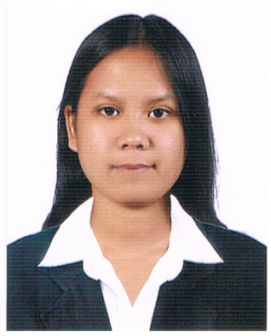
Name: Marife
Marife.348498@2freemail.com

PROFILE SUMMARY

Highly motivated, confident and hard working person graduated having the degree of an IT. Possessing ample knowledge in computer like web designing, MS office, technical support and ability to fix basic computer issues, as a graduate of an IT I was mold to do task as a team and improve myself as an individual professional. Optimistic with leadership skills, flexible which I can easily cope up with the environment and lastly have own initiative to do task even under pressure to meet challenging deadlines with determination to succeed.

EDUCATIONAL BACKGROUND

Year 2010-2015
BS Computer Science majoring Information Technology (IT)
Western Mindanao State University
Graduate with Leadership Award and Service Award

December 2014
Certificate of Participation in Google DevFest and Workshops
Using AppScript, HTML, Google Online Marketing, Google Apps, and Design Thinking
July 2014
Certificate of Completion in Mobile Game Development Training
Using Eqela
November –March 2015
Certificate of Completion of On-the-Job Training/Internship
In TESDA-IX (Technical Education Skills Development Authority)
As Project Manager and Test Engineer
Developing system for TESDA monitoring student records, training process and certification records, it is a web based system.

Secondary Year 2005-2009
Curuan National High school
Graduate with Service Award

Elementary Year 1999-2005
Sapamanok Elementary School
Graduated with Valedictorian Award

PROFESSIONAL SKILLS

- Able to read programming codes Java, C#, Visual Basic, PHP, MySQL, C ++ and HTML
- Proven ability to work as a team Project Manager handles the team documentation, project schedule and frontline of team development, ensure that the project reach its deadline
- Test Engineer ensures that the system development works according to functionality with no error and complete.
- Strong Technical Support and Customer servicing
- Experience in MS Office (Excel, Word and PowerPoint)
- Average in Adobe Photoshop and Adobe Flash CS6
- Written and verbal communication skills

PERSONAL SKILLS

- Creative in designing gift cards, birthday cards, invitation cards
- Researcher
- Hard-working
- Enjoy competitive environment
- Past time hobby in writing thoughts, poems, and short stories
- Good listener
- Time Management
- Knowledgeable in sales

WORK EXPERIENCE

2015-2016
WNS Global Services Philippines INC
A global BPM/BPO (Business Process Management/ Business Process Outsourcing) Company
Associate-Ops/Sales Associate under Operation Management

Duties/Responsibilities:
- Demonstrating outstanding customer service
- Ensure that the customer has the satisfaction
- Selling skills, selling floor stocked and ready for sales events
- Answering queries, assessing customers needs and providing assistance
- Remain knowledgeable on products offered and offer and discuss available option
- Team up with co-workers to ensure proper customer service

May 2015-November 2015
Polytechnic College
Project Manager in developing windows application

Duties/Responsibilities:
- Plan, budget, oversee and document all aspects of the project
- making sure that the scope and direction of each project is on schedule
- always the frontline of the team

