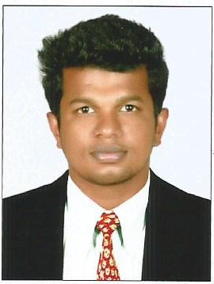
ABIN
ABIN.348515@2freemail.com

CAREER OBJECTIVE

To succeed in an environment of growth and excellence and earn a job which provides me job satisfaction and self development and help me achieve personal as well as organizational goals.

EDUCATION:

MBA (Shipping & logistics )at St.Britto’s College, Chennai. (65 % 2012-2014)

BA. Economics, S.B. College C hanganassery( 59 %, 2008-2011 )

HSC – Govt. HSS Kurichy( 55 %, 2006-2008)

SSLC - Govt. HSS Kurichy( 55 %, 2006)

Work Experience

June 2011 to march 2012 as office assistant at Kiran Global Chems Limited

Aug 2014 to Feb 2015 as EXIM Assistant Manager at Kiran Global Chems Limited

INTERNSHIP PROGRAMMES:

INDEV - ICD, Irungaatukotai.

Training given on: ICD Documentation Procedures.

Kiran Global Chemicals, Kilpauk.

Training given on: Exim Procedures.

DP World, Port of Chennai.

Training given on: Port & Terminal Handling Operations.

M&R Spedag Logistics, Chennai.

Training given on: Clearing & Forwarding.

Good Rich Maritime, Chennai.

Training given on: Liner trade & NVOCC Operations.

Ennore Cargo Container Terminal.

Training given on: Container Freight Station.

Airport Authority of India, Chennai.

Training given on: Export & Import Procedures.

INDEV - Air Freight Station, Chennai.

Training given on: Air Cargo Management.

Martech Surveyor & Insurance, Chennai.

Training given on: Cargo & Ship Draft Survey.

CONFERENCES

Organized:

VIGIL 2014

Vision in Global and Indian Logistics.

Chennai.

Attended:

Cargo Scope International Conference

Topic: Scope of Logistics

Chennai.

CO & EXTRA CURRICULAR ACTIVITIES:

  - School level Kabaddi Player.

TECHNICAL SKILLS

Operating Systems:

All versions of Windows.

Software’s known:

Microsoft Office

PERSONAL DETAILS:

Name: Abin

Date of Birth: 27-04-1991

Languages Known: Malayalam, Tamil, English& Hindi

Marital Status: Single

Nationality: Indian
Declaration:

I hereby declare that all of the above furnished information are true to my Knowledge and belief.

