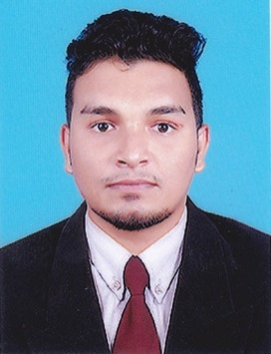
CURRICULUM VITAE

PRASOON
PRASOON.348558@2freemail.com

OBJECTIVE

Seeking a suitable placement in a professional organization with an opportunity for career growth. I am submitting my application with the hope of accomplishing my lofty objectives in life. It will be my best endeavors to merit your confidence and satisfaction. If you will be appointed me so my activities under your enter satisfactions.

EDUCATIONAL DETAILS

- Secondary School Leaving CertificateIssued under the Authority of Government of Kerala.
- Plus Two
- Degree (B.Com)
TECHNICAL KNOWLEDGE:

- Microsoft Office (MS word, MS Excel & PowerPoint)
- Tally & Peachtree
- Have valid Driving License (Indian)

LANGUAGES KNOWN

- English , Hindi, & Malayalam

PERSONAL INFORMATION

Date of Birth : 23-03-1992
Sex : Male
Nationality : Indian
Marital Status : Single
Religion : Hindu

WORK EXPERIENCE

- Worked as a Sales&Marketting Executive in Brothers wholesale and retailFootwear company -Kanhangad, Kerala –India for Two years .
- Worked as a MO in Indusind Bank Ltd. Kanhangad Two Years.

SKILLS

- Excellent oral and written communication skills
- Well Disciplined and punctual.
- Good presentation skills
- Customer service skills
- Inter personal skills.

PERSONAL STRENGTH

- Sincerity
- Self Confidence
- Responsible
- Good Team Worker
- Leadership quality

DECLARATION
I here by declare you that the information provided above is true and best of my knowledge and belief I understand that in the event of any information being found false or incorrect my candidater / appointement is liable to be cancelled / terminated

