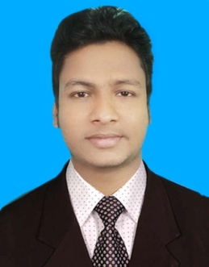
RESUME
OF

MD. ANISUL
ANISUL.348614@2freemail.com

OBJECTIVE :

To build up a challenging career in a well reputed organization where I can utilize my gathered knowledge effectively and get the scope of career development through evaluation of my competence.

PROFESSIONAL BACKGROUND :
Prime AMR Exchange
( Distributor of bKash Limited )
Agrabad ,Chittagong
Position : Distributor Complaince Officer ( IT BASE )
Duration : Aug 2016 to Till now

IOE ( Bangladesh ) Limited,
5 Rajuk Avenue Dhaka-1000
Position : Junior IT Engineer
Duration : April to July 2016.

ACADEMIC BACKGROUND :

a) Name of the Exam : Diploma in Computer Engineering
Institution : Bangladesh Sweden Polytechnic Institute,
Kaptai, Rangamati.
Board : Bangladesh Technical Education Board
Session : 2011 - 2012.
Passing year : 2015
Result : CGPA 3.21 out of 4.00

b) Name of the Exam : Secondary School Certificate (Vocational)
Institution : Technical Training Centre (70021),
Nasirabad, Chittagong
Board : Bangladesh Technical Education Board

Trade : General Mechanics
Session : 2008
Passing Year : 2010
Result : GPA 4.36 out of 5.00

TRAININGS :

- Institute Name : New Horizons CLC, Chittagong
Subject : Cisco Certified Network Associate (CCNA)

- Institute Name : New Horizons CLC, Chittagong
- Subject : Red Hat Enterprise Linux Essentials ,
System Administration, Network Services &
Security Administration

IT SKILL :

  - Networking ( Configuration & 1st level support )
  - Good knowledge about (CCNA)
  - Good knowledge about Red Hat Enterprise Linux
  - Good knowledge about System trouble shooting
  - Good knowledge about Hardware
  - Basic knowledge oracle 10.1g

