Hani
Hani.348658@2freemail.com

Web Designer/Video Designer

Personal Information

Visa Status: on visit from 11th Feb 2017 to 5th May 2017

Nationality: Pakistan

Marital Status: Single

Religious: Islam

Date of Birth: 7th April 1996

Career Objective:

To achieve the position of ‘Web Designer & Video Designer’ in the organization where I can utilize my creative skills in narrating the episodes and giving it a dramatic touch, while growing in the industry.
Summary

Two Years work experience in the field of Web Designing & Video Designing one year before & one year after completing Diploma of Film and TV Video Production . Ability to cut, uncut and synchronize details of the stories in the required format. Proficient in Web Designs and editing videos and the promos for various production and entertainment companies.
Well versed with the techniques of web Designs and video production and editing to meet the varied needs and preferences of the industry.
In-depth knowledge of the latest Web Designing & video editing system and the latest software used in the industry.
Excellent interpersonal skills and retail management experience to have better and strong customer relations.
Experience of providing the technical expert advice and direction on media projects as when required.

Work History

Multimedia Designer Jan-2016 - Dec-2016 Logiks IT Solutions

At least 1 Years’ experience in Web/Graphic and Multimedia Designing at Logiks IT Solutions.
Web Designing

Documentary Design

Video Editing (Linear & Non Linear)
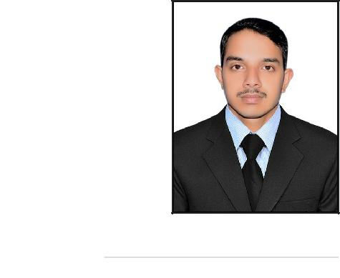

Skills

Adobe Photoshop cc

Adobe Premiere cc

Adobe Dreamweaver

Adobe After Effect cc

Adobe Audition cc

Cinema 4D

SKILLS PROFILE:

Hardworking, Punctual and Devoted to work.
Verbal Communication- Dealing with Customers and office staff over telephone and in person.
Writing expertise-Communicating with customers in written and via e-mail Languages Proficiency- Well conversant in English, Urdu and Punjabi Analytical skill- Posses good analytical skills.
Decision making- Can work under pressure without supervision and can make decisions independently on situation basis.
Target achievements- Have got target driven personality and meet the given deadlines
Team Work- Team working skill

developed through working with

junior staff, colleagues and seniors.

Computing skills: a. MS Office-

Competent user of Microsoft Word,

Power point , excel, Internet, Corel

Draw and Photoshop and Adobe

Premiere.

Internet- Proficient in using ( Web

Sound Designing

Web/Graphic and Multimedia Designer Feb-2014 - Dec-2014 Dsign Works Advertising Co

At least 1 Years’ experience in Web/Graphic and Multimedia Designing at Dsign Works Advertising Co.
Video Editing (Linear & Non Linear)

Television Comercial Design

Sound Designing

Web Designing

Web Developing (Statics)

Education

Multimedia Designing 1-APR-2012 - 31-SEP-2012

Dsign Works Computer Center

Adobe Photoshop

Adobe Dreamweaver

Adobe Flash

Adobe Premiere

Coral Draw

Film and Tv ( Digital Film Production ) July 2015 - December 2015

National College of Arts Lahore

Script Writing

Story Boarding

Camera

Lights

Sound

Post Production

1.Adobe Premiere CC 2. Adobe Photoshop CC 3. Adobe After Effect CC 4.Adobe Audition CC 5.Cinema 4D 6. Final Cut Pro

DAE Electrical 12 July 2012 - 12 June 2015

PUNJAB BOARD OF TECHNICAL EDUCATION

Web Designs

Browsing, email ) Have ability to learn new packages quickly. Installation-I can install and repair all kind of computer works.

Documentary Design

