348763@gulfjobseekers.com
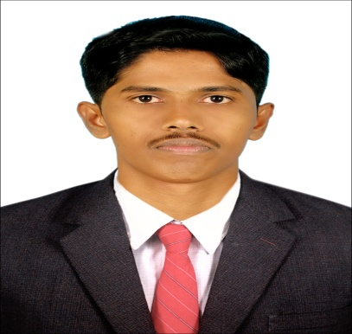

OBJECTIVES :

To chase the field with full zeal and caliber, and to exhibit my maximum potentiality in terms of creativity, innovation, hard work and thereby be an asset to organization. Look forward
to work in a professionally challenged environment, conductive for gaining professional
experience& development.

EDUCATIONAL QUALIFICATION:

◻ B. Com from MRK college of Arts and Science, in
Pazhanchanallur (2015).
◻ 10th Std Completed in PRG Hr. Sec. School – Kattumannarkoil
◻ 12thStd Completed in PRG Hr. Sec. School – KattumannarKoil.

PROFESSIONAL EXPERISANCE:

Organisation | Job Title
Cameo corporate services | Airtel QC team Leader.
intelenet global services Pvt. Ltd. | Accountant Officer, Chennai
ICICI Bank | Credit Card Sales,Chennai
EXTRA CURRICULAR ACTIVITIES
- Commerce department Cricket Team captain.
- Social Service awareness Program contacting in my native.
- NSS (National Service Scheme)

Other Skills :
- PGDCA
- Tally

Hoppies :

- Reading Motivational Books
- Playing And Watching cricket
- Solving Puzzles
- Reading News Paper
AIM :
To reach a high level in Society.

DECLARATION :
I hereby declare that the above said facts are correct to the best of my knowledge.

