Jamal
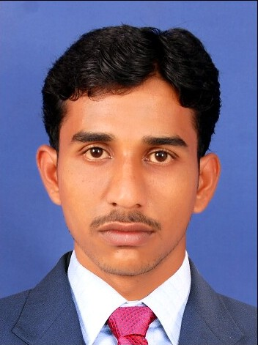
Jamal.348812@2freemail.com
RESUME
Objective:
Seeking for a challenging and rewarding career in a
Reputed organization which offers oppurtunities to explore my
Potential through continuous learning, growth and innovation.

Qualification

- Bachelor of Engineering in Electrical and Electronics Engineering in J.P.College of Engineering at Tenkasi(2008-2012) .
Self-appraisal:
- As a quick learner with positive attitude and ability to work in a team environment.
- Installing & Maintaining Security related Devices in Buildings
- Knowledge about Hardware and Basic Network
- Basic Knowledge in Electrical and Mechanism.

Work Experience

  - Company Name : RUNMAX SOLUTIONS ( 2012 June to Nov 2014 )
  - Designation : CCTV Engineer

Responsibilities

- Providing ongoing service, repair and maintenance of varied CCTV systems.
- Maintaining healthy customer relationship at all times.
- Communicating with field Engineer and taking his assistance when required.
- Troubleshooting and provide service whenever required.
- Being aware of all contract possibilities and add on business
- Maintaining Time to Time activities and reports

EXPERIENCE 2
Company Name : NFS Technology (from Nov 2015 to Till now)
Designation : ATM Service Engineer
Clients : Mashreq Bank, CITI Bank, ADIB Bank, Hilal Bank

CCTV System with Network Packet and Email Integration:

Installed DVR with special features like surface motion, masking, and network packet capturing to showing the Customer transaction details in recorded and live video.

E-mail integration will help to maintain the CCTV system and prevent the customer data from ATM skimmers.

ATM -Card production Kit (CPK) with alarm integration:

Anti-skimming is a technique, which used to prevent from criminals to copy personal data from the magnetic strip on an ATM card.

Installing the CPK with below electromagnetic integration devices to prevent the ATM’s from skimmers through CCTV and Anti-skimming utility (Alarm).

Anti-Trapping Kit(ATK) | Surface Detection Kit(SDK)
Tilt and Vibration kit(TVK) | ATM Door Open/close Sensor(MS)

Project

Client | Description
CITIBANK(UAE) | Anti-Skimming Device Installation.
Union National Bank (UAE) | Anti-Skimming Device Installation.
ADIB(Abu Dhabi Islamic Bank) | Anti-Skimming Device Installation.

Responsibilities

- Site survey to install the CCTV cameras and DVR with Anti skimming devices.
- Coordinating and getting calls from Data center (Banks)
- Materials arrangements.
- Scheduling for installation and maintenance of security devices
- 24 x 7 Customer Support to more than 100 ATM machines.
- Checking and confirming the calls Status with ATM data centers.
- Retrieving the videos from on site and remotely.
- Maintaining Time to Time activities and reports.
- Follow up and re-arranging the pending calls.

Languages known
English : Read, write and speak
Tamil : Read, write and speak
Malayalam : Speak

Declaration:

All the details stated above are true to the best of my knowledge. If you will give me a chance to serve under you kind control, I assure to perform my duty efficiently and up to the entire satisfaction of my superiors, along with the growth of the organization in the challenging environment.

