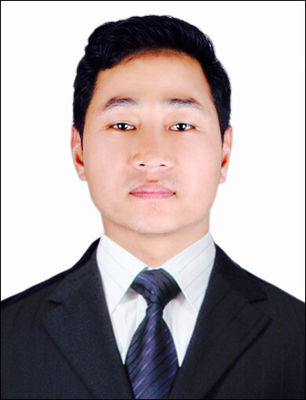
Curriculum Vitae

Name ​​: Sarva
Email : sarva.348821@2freemail.com
Objective
Seeking a position to utilise my knowledge and skills in growth oriented organisation to propel the growth of both.
Technical Skills
- Expert in quality to fulfill the customer requirement.
- Smart coordinator while leading team members.
- Knowledge on Huawei BTS (BTS3900, TP48200) and ZTE.
- Knowledge of Huawei MW links.
- Knowledge of DG’s operation.
- Handling of various indoor and outdoor equipments.
Work Experience
- GTL Nepal Pvt. Ltd.
Telecom Engineer Feb 2015 to May 2016
GTL Limited is a leading infrastructure Services Company focused on telecom. GTL Nepal Pvt. Ltd. provides network services in FLM department for Ncell.
Responsibilities
- Responsible for operation and maintenance of sites, day to day alarm handling and fault rectification.
- Coordinating with various teams for the smooth functioning and for fault free network.
- Responsible for Performance Acceptance Test (PAT) of new Sites.
- Prepare reports to keep track of various activities such as preventive maintenance, rectifications, etc.

- Eastern Transformer Industries
Electrical Engineer Jan 2013 to Jan 2015
Eastern Transformer Industries is a private owed transformer manufacturing company. Its manufacturing range extends from 5KVA to 500KVA, 11KV class. It also provides transformer full repair services.
Responsibilities
- Responsible for solving the technical problems of production process.
- Responsibility to maintain and improve QMS of company.
- Coordinate with clients and suppliers.
- To preserve technical documents and provide them for production and for participation in tender.
- Perform transformer testing i.e. Insulation resistance test, Voltage ratio test, Winding resistance test, Load and No-load test, etc. as per IEC 60067 standards and prepare test certificates.
- Conduct pre-delivery testing during customer inspections.
Qualification
- Bachelor of Engineering in Electrical and Electronics from Visvesvaraya Technological University, Bangalore, India.
Software Skills
- Operating Systems​​ : Microsoft Windows and MacOS.
- Programming Languages​ : C and C++.
- Software : Ms Office, Auto CAD(Basic), Solid Edge.
Strengths
- Punctual and hardworking.
- Enthusiastic to face new challenges.
- Ability to adapt to new environment.
Hobbies
- Traveling.
- Adventure.
- Watching and reading news.

Personal Details
Gender ​​​: ​ Male
Date of Birth ​​: ​ 18th June, 1987
Marital Status : Single
​​​Nationality : Nepalese
Languages Known ​​: ​English, Hindi and Nepali (Read, Write and Speak).

