CURRICULUM VITAE
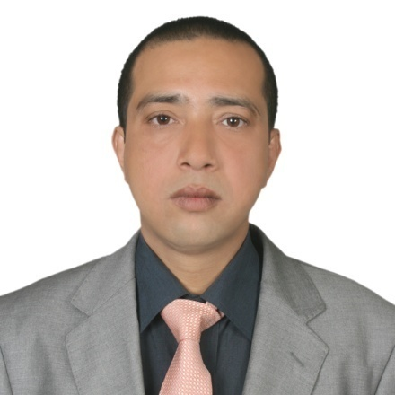
DEBABRATA
DEBABRATA.348913@2freemail.com

OBJECTIVES:To gain employment with a company where my experience and knowledge can be used effectively.

EDUCATIONAL QUALIFICATIONS:
Rail Transport Management (one year Diploma)
RailBhavan ,Raisina Road , NEW DELHI – 110001, Issue : 1997
PORT DEVELOPMENT&Management (2yearsDiploma)
Rail Bhavan ,Raisina Road , NEW DELHI – 110001, Issue : 2003
Financial Accounting System (6months)
Computer Traning Institute State Youth Centre, Kolkata – 700009,Issue: 1997
Bachelor of Commerce from Calcutta University (3years)
Calcutta University, Calcutta – 700009,issue: 1995
Higher Secondary Certificate (W.B.C.H.S.E)
S.A -Vidhya Pith - DebogramNadia, West Bengal council of Higher Secondary Education, W.B. India.Achievement year 1991
Secondary School Certificate (W.B.B.S.E)
Purbajagada Nanda purSaha para High School , Nadia ,West Bengal Board of Secondary Education , W.B. India. Achievement year 1989

PROFESSIONAL STRENGTHS:
Possesstwo yearof experience asAssistant Accountantin Mahindra & Mahindra Tractor division of Golden Motors PVT. LTD.Palassy , West Bengal . India.

- Possess two year of experience as accountant & Reception in Charge ISKCON in Maya Pure, Nadia, WestBengal,and India.
- In-depth knowledge of excel,word, office, internet.
- Ability to shoulder responsibility.
- Possess good communication and team spirit Knowledge of Computer Fundamental, Computer Networking.
- Possess excellent working skills in accounting.
- Ability to complete assigned course within limited time period
- Affiliate Student member of the chartered Institute of

Transport Founded 1919 Incorporate by Royal charter

1926.(Roll No AF-068) 80 Portland place London.

W1I4DP. Great Britain.

* Affiliate student member of the Institute of Logistics

And Transport, Earl street Court, Earl street Road.
- P.O.Box-5787 CORBY, NORTHANTS, NN174XQ. (UK).

TECHNICAL SKILLS:

- Typingin data entry.
- Making file,folder,office workexcel .
- Operating Systems: Windows98, Windows2000, Windows XP, Windows Vista, Windows 7,
- Office Package: Microsoft Word, Microsoft Excel, Microsoft Access, Microsoft PowerPoint, Microsoft Outlook Express.

Windows 98, Windows 2000, Windows XP, Lotus

Ms Word, Ms Excel, Tally 5.4, 6.3, 7.2
- Mail Marge, Internet

PROFESSIONAL EXPERIENCE:
I smart Global Pvt. Ltd Company,data entry operator, Durgapur, west Bengal, Jan 2007 to Jan 2008.
Position: On- line Mobile cap- entry of I smart Company

- Handled the tasks of teaching concepts like Computer Data – entry & mobile on – line data entry.
- Responsible for data - entry checking capentry.
- Responsible for providing guidelines to cap entry to data – operator & help them to complete work.

SAFAR RENT A CAR, BIN – OMRAN , DOHA – QATAR ., PO BOX - 15789 from - 21th April 2009 to 21stApril 2014.(Contractperiod)

Position:Office in Charge &Accountant (Full Time)
- Handled the maintenance and upgrade of accounts & office staff handle.
- Maintenance of saloon car Honda accord &city.
- Maintaining driver routine work limousine system.
- Provide one to one support to the Customers and use different types of account car rent&limousine servicework.

PERSONAL INFORMATION:
- Date of Birth: 19/07/1974 ( 19TH JULY 1974 )
- Sex: Male
- Marital Status:Married
- Blood group : 0+
Languages:
- English Languages: Speaking, Reading & Writing,
- Hindi: Fluent in Speaking.
- OTHER TRATIS : Tend to place a lot of trust in a lot of people which in Many occasions has been rewardingly reciprocated

