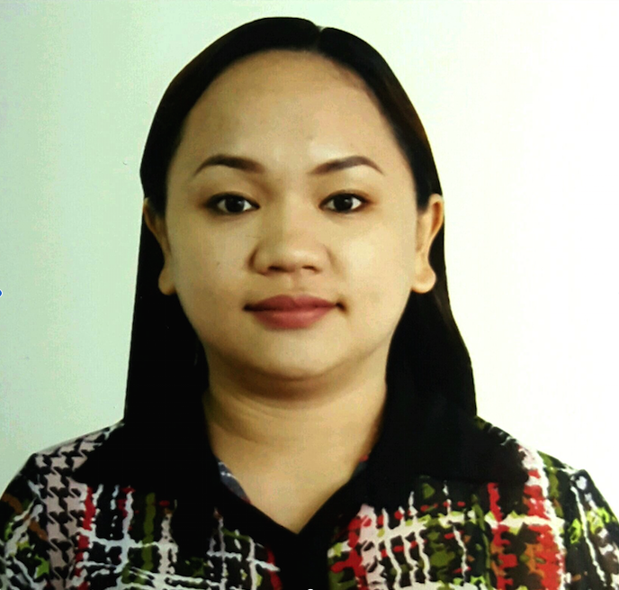
VIVIAN

VIVIAN.348938@2freemail.com
SUMMARY

CPA, with vast 10+ years’ experience dedicated in accounting and finance functions such as general accounting, accounting analysis, reporting, budgeting/forecasting, revenue recognition, accounts payable, accounts reconciliations, accounts receivable, billing, payroll, Tax and inventory. Strong knowledge in accounting ERP programs including SAP, JDE Edwards/Oracle, AP Workflow, Sharepoint, QuickBooks and MS-Office applications - excel, word and powerpoint expert. Proven analytical skills as well as strong communication, interpersonal and organizational skills.
CAREER OBJECTIVE

To obtain a position in the field of accounting that would best fit my qualifications and develop further my knowledge, talents and skills for continuous career improvement.
WORK EXPERIENCE

XEROX - PHILIPPINES (Xerox Shared Services Phils. Inc., ROHQ)
Address: 7F One E-com Bldg. Palm Coast Ave., MOA Complex, Pasay City, Metro Manila 1300 Philippines
Section: Internal Finance and Accounting
Position Held: Senior Accountant - May 12, 2014 to December 29, 2016

Duties & Responsibilities
- General
- Expert on recording of revenues, expenses, intercompany entries, allocations, accruals, allocations, adjustments and Inter-Company related entries every month-end close and year-end close.
- Prepares, reviews, verify the accuracy and completeness of journal entries; ensuring that entries and financial records adheres to International Accounting Standards and established controls, accounting principles and policies.
- Strong knowledge on End to End General Accounting, Reporting and Analysis.
- Knowledge in Financial Planning/Forecasting and Budget Preparation.
- Validate Billing Files and ensure to adhere revenue rates/charges with approved Contracts/Agreements.
- Prepare and Analyze Accounts Reconciliation for Balance Sheet Accounts.
- Validate and record Asset Capitalization with complete approval and CAPEX supports.
- Provide high level support to Accounting Business Partners in addressing ad hoc & queries.
- Evaluates current accounting processes and proposes improvements for operational efficiency.
- Prepare and Compute Quarterly Profit Bonuses of Operations Managers.
- Other Tasks
- Prepare Desk Top Procedures (DTP) for internal accounting procedures.
- Process Migration for US/UK Centers. Process capture through WEBEX conferencing trainings.
- Monitors, Evaluates, and Identifies Process Improvements.
- Member of Internal Audit Team that regularly reviews processes randomly and provide suggestions for process improvement, specially Internal Control related.

SOFTWARE: JD Edwards Enterprise One, ODM Online Data Management, AP Workflow, ESSBASE, Intercompany Processing System

SHELL BUSINESS OPERATIONS – August 17, 2009 to April 30, 2014
Address: 21st Floor, Solaris One Bldg. Dela Rosa St., Legaspi Village Makati City 1229 Philippines

Section: Manage Hydrocarbon Inventory Department (Contracts and Pricing – ASIA/EUROPE)
Position Held: Hydrocarbon Inventory Accountant - July 1, 2013 to April 30, 2014

Duties & Responsibilities
- Skilled in creation and update of Sales and Purchase Contracts in SAP related to Hydrocarbon Products.
- Validate the completeness and correctness of contract details based on the standard rules.
- Ensure that request is appropriately approved base on approver’s role and Manual of Authority.
- Manually set-up the contract in SAP accurately based on set out in the standard Work Instruction and country specific guidelines.
- Skilled in creation and update the formula and fixed Pricing of Sales and Purchase contract in SAP related to Hydrocarbon Products.
- Validate the completeness and correctness of pricing details based on the standard rules depending on the pricing type.
- Ensure that request is appropriately approved base on approver’s role and Manual of Authority.
- Manually set-up the pricing of the contract in GSAP accurately based on standard rules and procedures.
- Proficient handling of queries/issues/request raised by stakeholders related to contracts and pricing.
- Investigate queries raised by stakeholders related to contracts issues and inquiries.
- Analyze and resolve pricing issues raised by the other department affected on the pricing.
- Provide administrative support for effective and efficient office operations.

- Super User on the system and process migration from Shell US Centers.
- Lead as a trainer to new hires for the process to be migrated and guide them with admin matters.
- Understand and execute effectively applicable SOX and business controls.

Section: Expenditure –Finance Operations Department (AP Delivery-Downstream EUROPE)
Position Held: Accounts Payable Analyst - August 17, 2009 to June 30, 2013

Duties &Responsibilities
- Expert in daily end to end Accounts Payable processing in SAP and ensure that finances are made effectively and accurately.
- Process/Post invoices in accordance with company standard procedures and agreed-upon country specific guidelines.
- Strong Knowledge on withholding taxes, VAT and other tax related codes.
- Exercise diligence in making daily payment run.
- Ensure Purchase Orders are complete and with accurate Goods Receipts.
- Exercise diligence in reviewing and unblocking invoices with issues.
- Ensure delivery within agreed global and local performance metricsl/KPI.
- Skilled in handling queries/issues/request raised by stakeholders.
- Maintain high quality of work despite pressure when handling Urgent Payments or critical invoices (Tax, VAT, down payments, legal, etc.).
  - Strong analytical skills in investigating queries and issues raised by stakeholders.
  - Liaise with vendors via their local language (through online/third party translator).
- Provides support on the reports to be submitted to the higher management.
- Parked and Blocked Focal- Provides support for identified action items from the unpaid invoices Report.
- Monthly Reconciliation and Statement of Accounts to all customers per internal procedures.
- Focal of the team for ISP VENDORS (Internet Service Providers).
- Ensures that all ISP invoices are processed and paid on time.
- Update the team with new ISP vendors.
- Focal of the team for RTV (Return to vendor) implementation.
  - Ensure that all Non-compliant invoices were filtered and returned to vendor.
- Guarantee that every transaction complies with the financial policies and procedures.
- Comprehend and operate effectively applicable SOX and business controls.
- Sustain the verification of invoices and requisition for goods and services.
- Ensures that vendor details on Master Data are up to date.
- Handles French vendor calls and Queries.
- Identify opportunities for process improvements in assigned and related tasks.

SOFTWARE: SAP version P94 and P71, Citrix SER Brainware Verifier

BPO INTERNATIONAL, INC.
Address: SGV Bldg. II, Ayala Avenue, Makati City, Phils.
Section: Finance Payroll Accounting Section
Position Held: Payroll Analyst- May 23, 2008 to August 15, 2009

Duties & Responsibilities
- Partakes in staff development through accomplishment of performance feedback reports for junior staff handled on each engagement.
- Expert in review and processing of payroll needs:
- Skilled in review and approval of final computed payroll, processed by payroll associates assigned on certain clients.
- Proficient computation of management employees’ regular earnings.
- Proficient computation of regular and statutory deductions, remittance and filing of contributions to various government agencies, i.e. SSS, Philhealth, HDMF.
- Computation and monitoring of other income, such as, non-taxable and taxable 13th Month Pay, other bonuses etc.
- Final pay computation of resigned employees.
- Skilled in Annualization of payroll at year-end, including preparation and filing of Alphalist (Alphabetical list of employees from whom taxes were withheld) and other BIR/Government requirements.
- Skilled in accurate Timekeeping
- Analysis, computation of Overtime.

SOFTWARE:HR System (Co. built in System)

KAPUNAN & ASSOCIATES ACCOUNTING FIRM (ATTY.RHODORA G. KAPUNAN)
Address: West Avenue, Quezon City, Phils.
Section: Accounting Section
Position Held: Accounting Staff - November 30, 2006 to May 21, 2008
Duties & Responsibilities
- Assist in preparation on clients Financial Statements using Quickbooks.
- Proficient in preparation and recording of journal entries of revenues and expenses using Quickbooks.
- Preparation of Monthly Sales Report and Ending Inventory Report for FS preparation.
- Preparation of checks of clients’ company expenses.
- Accurate Review of processed payroll for the clients, prepared by accounting associate.
- Skilled in preparation of Alphalist and computation of 13th month at the year end, for clients’ payroll.
- Expert in overall payroll processing of other clients’ payroll.
- Monthly computation and payment of government mandatory contributions (SSS, Pag-Ibig, Philhealth and BIR).
- Processing of clearance and quitclaims of resigned and end-of-contract employees.
- Weekly preparation of checks for company expenses including petty cash fund.
- Conduct the audit of the end-of-the-month physical inventory count of clients.

SOFTWARE: Quickbooks and Payfast System

SKILLS/APPLICATION

Strong knowledge in computer software applications, e.g. JD Edwards/Oracle, SAP, ODM Online Data Management, AP Workflow, ESSBASE, Intercompany Processing System, Blackline, Sharepoint, Citrix SER Brainware Verifier, HR System, Quickbooks, Payfast System, MS Word, MS Excel (advance), MS Outlook, Power point and Internet.

EDUCATION / ACHIEVEMENTS

CERTIFIED PUBLIC ACCOUNTANT
Professional Regulation Commission - Philippines
Issued: November 2012

POLYTECHNIC UNIVERSITY OF THE PHILIPPINES
Mabini Campus, Sta. Mesa, Manila, Phils.
Bachelor of Science in Accountancy
2002-2006

CULIAT HIGH SCHOOL
TandangSora Ave., Quezon City, Phils.
1998-2002

TANDANG SORA ELEMENTARY SCHOOL
TandangSora Ave., Quezon City, Phils.

1992-1998

SEMINARS AND TRAININGS ATTENDED

- US GAAP Refresher Training
Xerox Shared Services Phils., Inc. ROHQ
16th Flr 5Ecom Tower, MOA Complex, Pasay City, Phils.
June 14-16, 2016

- Competent Speaker Level 1
Shell Shared Services Asia.B.V.
RCBC Plaza Tower 2, Legaspi Village Makari City, Phils.
June 13-15, 2011

- GSAP TRAINING (DOWNSTREAM ONE- FINANCE)
Shell Shared Services Asia, B.V.
21stFlr Solaris One Bldg. Dela Rosa St.,Legaspi Village Makari City, Phils.
June 2010-July 1, 2010

PERSONAL DATA

Age : 31
Date of Birth : May 6, 1985
Sex : Female
Civil Status : Married
Citizenship : Filipino
Language Spoken : English (Fluent)
Religion : Roman Catholic
Visa : Husband Sponsorship

