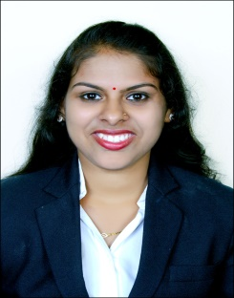
Anusha
Anusha.348949@2freemail.com

Career Objective |  | To be a challenging Management professional by leveraging on the expertise gained in the area of Finance and keep upgraded to meet the organizational and personal goals
Educational Qualification |  | Masters of Business Management (MBA)(FINANCE)  From SDM PG Centre For Management Studies And Research, Mangalorein 2016,  Bachelors of Commerce  From Karnataka state open University, Mysore in 2013
Certification |  | Dual specialisation during MBA  Promotion and distribution, Consumer behaviour and research, International marketing, Service marketing
Academic projects |  | Study on “Ratio analysis with reference to Karnataka bank”  Karnataka bank, Mangalore.  objectives  - To estimate the returns and financial position of the bank  - To assess the growth of the bank  - To suggest the measures to improve their services  Key outcomes  - It can be stated that the financial performance of the bank seems to be satisfactory.  - Company short term solvency is not too good so that they should try to reduce their current liabilities.  - Bank should reduce their interest expenditure, because around 70percent of the total income is paid as interest. it lead to decrease in profit margin.  Internship on “Study on customer satisfaction”  Harsha electronics pvt ltd” Mangalore  Objectives  - To study whether the customer satisfied with their service  - To measure the impact of the analysis on future sales.  - To ascertain the satisfaction level and its influences  Key outcomes  - It is found that majority of the customer re-enter the store because of Harsha provides good customer services.  - It is suggest that Harsha should reduce its price on its products, as it is more compare to other outlet in Mangalore.
PROFESSIONAL EXPERIENCE |  | Accountant at JALADURGA ENTERPRISES, Mangalore – from April 2012 to May 2014  - Maintenance of Accounts in Tally  - Preparation of Bank Reconciliations  - Sharing the monthly statements with customers  - Following up with customers for receivables  - Maintenance of vouchers
System Knowledge |  | Tally ERP- 9 | Peachtree |  | Internet
 |  | MS Word | MS Excel |  | MS PowerPoint
Personal traits |  | - Understand business requirements and work accordingly.  - Fast Learner with a spree to learn new technologies.  - Punctual, honest and committed to work.  - Able to work in both independent and team environment.  - Maintain effectiveness when experiencing major changes in personal work tasks or work environment  - Adjusts effectively to work within new work structures, processes, requirements, or cultures.
Declaration |  | I hereby certify that the particulars provided above are true to the best of my  Knowledge

