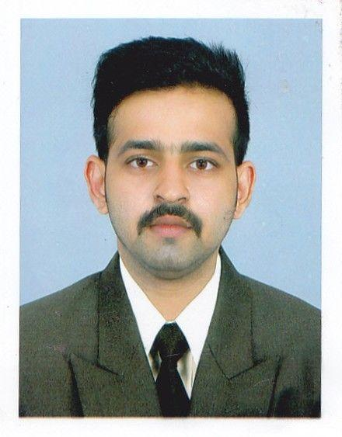JOSEPH
JOSEPH.348997@2freemail.com

Objective
I aspire to obtain a challenging career in a reputed company to enhance my skills and knowledge, transform them to become an asset for the organization’s growth and development.

Synopsis
- A highly motivated business management graduate

- Significant knowledge and interest in business development

Educational Qualification
Qualification | University/Board | Year | Percentage
BBA | Manipal University | 2015 | 60%
10+2 | Carmel Central school valapad; | 2011 | 51.00%
 | Thrissur,Kerala
th | St joseph’s English medium H S S, | 2009 | 80.00%
10​
 | (Eravu)Thrissur,Kerala

Computer Skills
- Ms-office

Previous Experience
- Worked as Guest Relation Executive in Food Mall ,Multi Cuisine Restaurant, Thrissur ,Kerala.

June 2015-Dec 2016

- Worked as Tele Verification Agent in Reliance Jio Telecom ,Aegis ltd, Banglore ,Karnataka.

Jan 2016 - Jan 2017

Hobbies
- listening to music

- Photography

- Travelling

- Surfing

- Riding

Industrial Visits
- PARLE PRODUCTS PVT LTD(BANGALORE)

Personal Profile

Date of Birth | th​ | Sept. 1992
 | 28​
Sex | Male
Marital Status | Single
Nationality | Indian
Languages Known | English, Hindi, Malayalam, Tamil,
 | Kannada

Declaration

I hereby declare that the information given here with is correct to my knowledge and I will responsible for any discrepancy.

​

