JAGANKUMAR
JAGANKUMAR.349030@2freemail.coM . 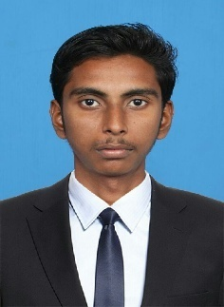

Summary

To Attain a challenging and Responsible position where I can contribute the best of my Academic background & Interpersonal skills and Efforts for the growth of the company.

Working Profile

Employer : Galaxy Engineering Pvt Ltd.(HVAC Products.)
No.30, 31.SamuvelNagar, Vadaperumbakkam, Chennai- 600 060.
Designation : Assistance Accountant.
Period : FromMay 2011- Jan-2017

Employer Profile

Galaxy Engineeringis one of the leading HVACand Ducting ProductsManufacturing Company in India
The company sales all over India

Educational Profile

B.com. Bachelor of Commerce at JHA AGARVAL AGARSEN COLLEGE Chennai – 600 060. Secured from 2008-2011.

H.S.L.C (COMMERCE) from 2007(The MuthiyalpetHigher Sec.School, Chennai –600 001

Technology expertise

- Operating system = Windows XP, Windows 7& 8

- Languages = HTML,

- Packages = Desktop publishing Adobe PHP.

- Accounting Package = Tally ERP 9.0 version.

Job Responsibilities

- Maintenance of ledger Records

- Taxation (Sales Tax ,VAT ,CST & Income Tax)

- BRS (Bank Reconciliation statement)

- Profit & Loss Account, Balance sheet.

- Account Finalization.

- Knowledge of Inventory Records & Warehouse Stock keeping.

- Communicate with customers / Business areas on progress and closure of an issue / work at first

Certification Courses

1.Tally ERP 0.9

2.Inventory Store Management ( TUV Rheinland International Certified )

Personal Details

Age & Date of Birth : 27& 15th AUGUST, 1989

Marital Status : Single

Nationality & Religion: Indian & Hindu

Mother Tongue: Telugu

Languages known

To Read, Speak & Write - English, Tamil

To Speak - Telugu

Declaration
I here by declare that above given details are true to my knowledge.

