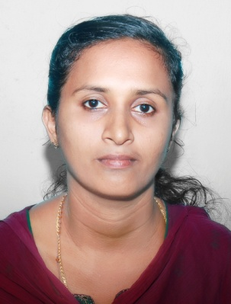
RESUME
ALEYAMMA

Aleyamma.349141@2freemail.com

OBJECTIVE
To obtain a position as a school teacher that will utilize my strong dedication to children’s development and their educational needs.

ACADEMIC QUALIFICATION

Sl.No | Education-Details | University/Board | Year of Study
1 | BEd. (Social Science) | M.G. University | 2009 – 2010
2 | MA Economics | M.G. University | 2007 – 2009
3 | BA Economics | M.G. University | 2004 – 2007
4 | Plus Two | Kerala Higher Secondary | 2002 – 2004
5 | SSLC | Public Examination Kerala | 2002

TECHNICAL QUALIFICATION
- MS Office
EXPERIENCE : (Total 5 Years as a Teacher)
- Position : faculty of Social Science (June 2015 to Feb’ 2017)
Employer : National College, Thiruvalla
Classes taught : 10th, plus one, plus two
Subjects : politics, sociology, Indian culture

- Position : Asst. Teacher in Primary section (June 2013 to April 2014)
Employer: Royal Public School Mumbai, Maharashtra
Classes taught: 5, 6, 7
Subjects: Social Science, G. K.

- Position : TGT Social Science (June 2011 to March 2013)
Employer : Carmel convent English medium school, Thadiyoor
Classes taught : 1st, 7,8,9,10
Subjects : Economics, politics, social studies

PERSONAL DETAILS

Father’s Name : Oommen Varghese
Marital Status : Married
Husband’s Name : Benny George
Nationality : Indian
Religion : Christian
Language Known : English, Hindi, Malayalam
Place of Issue : Trivandrum

DECLARATION
I hereby declare that all the above information’s furnished is true and correct to the best of my knowledge and belief.

Place: Sharjah
Date : 07-02-2017

