CURRICULUM VITAE
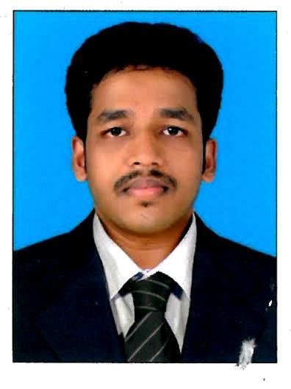

Anoop.349153@2freemail.com

ANOOP

CAREER OBJECTIVE

Seeking a career in radiology technician in a reputed hospital where I can fully utilize my skills, experience, and positive attitude, team spirit and service mentality to our mutual benefit and to work in challenging environment to produce better output every time through constant learning and implementing innovative ideas into the work.

BASIC ACADEMIC QUALIFICATION

QUALIFICATION | INSTITUTION | YEAR
Xth | MKM HSS , PIRAVOM | 2003
XIIth | GOVT: HSS, PERUVA | 2005

PROFESSIONAL QUALIFICATION

QUALIFICATION | INSTITUTION | YEAR
BRIT | VINAYAKA MISSIONS | 2014
 | UNIVERSITY , SALEM

EXPERIENCE

SI | INSTITUTION NAME | POST | DEPT | YEAR OF | PERIOD
NO |  |  |  | EXPERIENC
 |  |  |  | E
1 | ASTER MEDICAL | RADIOGRAPHER | RADIOLOGY | 10Months | SINCE
 | CENTRE, AL -QUOZ, |  |  |  | APRIL-2016
 | DUBAI
2 | CHOICE DIAGNOSTICS | RADIOGRAPHER | RADIOLOGY | 2.6YRS | NOV-2013
 | C/o EDAPPAL |  |  |  | TO
 | HOSPITALS, |  |  |  | APRIL-2016
 | MALAPPURAM,KERLA

CONTINUING MEDICAL EDUCATION

SI NO | COURSE | AUTHORITY | PERIOD
1 | RADIATION PROTECTION | DHA | NOVEMBER-2016
 | EDUCATIONAL PROGRAM

Technical Skills:

• CT - CT ANGIO- CORONARY ,

CEREBRAL ,CAROTID, PULMONARY ,BRONCHEAL

RENAL,ABDOMEN ,UPPER AND LOWER LIMB PERIPHERAL ANGIO ,

CISTERNOGRAPHY

ALL ROUTINE STUDIES .

• X-Ray- DIGITAL X-RAY

SPECIAL STUDY BARIUM CONTRAST

IVP, RGU, MCU, HSG FISTULOGRAM, COLOGRAPHY, SINOGRAM

ALL GASTROGRAPHIN STUDIES

MACHINES HANDLED.

CT Scan- 1.SIEMENS SOMATOM DEFINITION EDGE-128 SLICE,

2.GE BRIVO-325 DUAL SLICE.
X-Ray - 1. DR- SIEMENS,

2.CR- AGFA DRY VIEW 3.CR- FUJI FDR Smart F

REGISTRATION INFORMATION

License Type | Registration Council | Date of Registration
Life | INDIAN SOCIETY OF | August-2014
Membership | RADIOGRAPHERS AND
 | TECHNOLOGISTS

Strength;

*Confident and self motivated.

*Good Communication and interpersonal skills. *Can work under pressure.

*Sincere and committed to the work undertaken.

PERSONEL INFORMATION

Nationality : Indian

Gender : Male

Religion : Hindu

Marital Status : Single

LANGUAGES KNOWN

English, Hindi, Malayalam & Tamil

PASSPORT & VISA INFORMATIONS

DECLRATION

I affirm that all the information provided is true and correct to my knowledge and belief also. I am willing to provide any additional informations as and when required.

ANOOP

