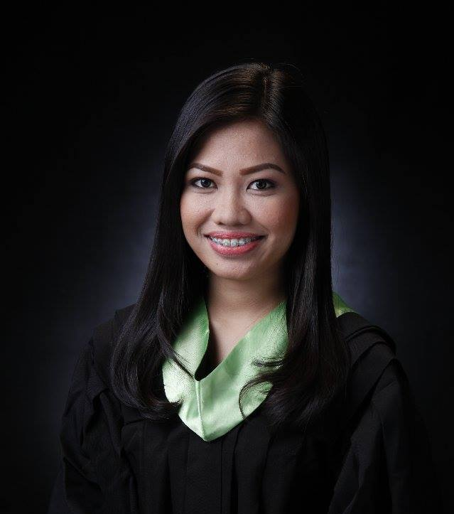
J-ANN

J-ANN.349156@2freemail.com

CAREER OBJECTIVE
A newly registered Medical Technologist with a bachelor’s degree in Medical Laboratory Science. I aspire to find a platform where I can make use of my skills and understanding in performing various tests, with accuracy and precision, in a laboratory setting and at the same time, gain knowledge and expertise for the career growth.

EDUCATIONAL BACKGROUND
Tertiary Centro Escolar University
Bachelor of Science in Medical Technology
Mendiola, Manila
S.Y. 2011-2015

Secondary Romblon State University-Science High School
Odiongan, Romblon
S.Y. 2007-2011

Primary Tumingad Elementary School
Tumingad, Odiongan, Romblon
S.Y. 2001-2007

ACHIEVEMENTS
2016 Registered Medical Technologist
Board Exam rating: 84.40%
2011-2013 Dean’s Lister

AFFILIATIONS

2014-2015 Red Cross Youth (Member)

2011-2013 COMPASS- Community Outreach Movement Pro-active
Service (Member)

2014 Shifts and Trends in Medical Technology Symposium
Centro Escolar University, Manila

Hands-on training on waterborne and neglected parasites:
Immunological, Molecular and Histopathological Diagnosis
Centro Escolar University, Manila

SEMINARS/ TRAININGS ATTENDED

Medical Technology Internship Training
May 1-October 31, 2015
Veterans Memorial Medical Center, North Avenue Diliman Quezon City

Phlebotomy Certificate
October 31, 2015
Veterans Memorial Medical Center, North Avenue Diliman Quezon City

Phlebotomy, Needlestick Injury and Waste Management
October 31, 2015
Veterans Memorial Medical Center, North Avenue Diliman Quezon Cit

WORK EXPERIENCES
- Student Assistant, Centro Escolar University, Medical Technology Department
(October 2013- 2014)
- Greet visitors/guests at reception desk
- Answer telephone, forward calls and take messages
- Assist with preparations for department’s summer responsibilities (which include but are not limited to first year to fourth year enrollment, student orientation)
- Maintain appearance of office, supply and storage closets
- Assist new students and staff for the queries about school matters

- Hematology Section Intern, Veterans Memorial Medical Center
(May 1- 25, 2015)
- Skills in proper collection of blood and necessary precautions
- Performs the Clotting Time, Bleeding Time and Clot Retraction Time
- Coagulation Tests (PT, APTT)
- PreparesPeripheral Blood Smear

- Out-patient Department and Reception Intern, Veterans Memorial Medical Center
(May 26- June 20, 2015)
- Assist the patients in reception area
- Extracts blood samples from patients of hematologic, chemical and serological examinations

- Clinical Microscopy and Parasitology Section Intern, Veterans Memorial Medical Center
(June 21- July 17, 2015)
- Prepares sample for urinalysis and fecalysis
- Prepares sample for Fecal Occult Blood Test

- Clinical Chemistry Section Intern, Veterans Memorial Medical Center
(July 18- August 14, 2015)
- Collection of blood for STAT requests during shifts
- Does data entry/encoding of laboratory requests and results in the computer

- Bacteriology Section Intern, Veterans Memorial Medical Center
(August 15- September 9, 2015)
- Prepares the different media, reagents and stains used for routine procedures
- Skills in collection and handling of specimen
- Prepares slide for gram stain
- Isolates microorganisms through the different media and biochemical reactions
- Perform antibiotic sensitivity testing patterned after the Kirby-Bauer method

- Immunology and Serology/Blood Bank Section Intern, Veterans Memorial Medical Center
(September 10- October 5, 2015)
- Skills in blood donor collection and processing
- Performs cross-matching

- Histopathology Section Intern, Veterans Memorial Medical Center
(October 6-31, 2015)
- Prepares cytology smears and cell blocks from different sources
- Does the specimen accession, recording and filing of results

- Worked at MARITIME MEDICAL LABORATORY CLINIC(June 2016-January 2017)
- Phlebotomy, Reception Area, Hematology, Clinical Microscopy, Serology, Clinical Chemistry, Drug Test Capturing and Encoding

PERSONAL QUALITIES
- Punctual
- Proficiency at observing safety precautions and handling of infectious specimens and understanding laboratory procedures
- Excellent interpersonal skills to interact courteously and effectively with co-workers, physicians and others.
- Willing to learn new skills and techniques
- Eager to be trained as Clinical Laboratory Scientist
- Devoted to the work assigned

PERSONAL INFORMATION
Date of Birth: December 25, 1994
Age: 22
Gender: Female
Status: Single
Religion: Baptist
Citizenship: Filipino

Occupation: OFW
Occupation: Mechanical Plant Supervisor I (Operator), MMDA

I hereby certify that the above information is true and correct to the best of my knowledge and belief.

