RESHMY
Reshmy.349215@2freemail.com
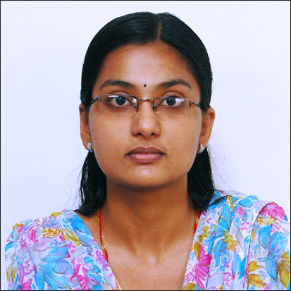

…………………………………………………………………………………………………………………………………………………

CAREER OBJECTIVE

To pursue a successful career that places me in a challenging position with a fast-paced and learning environment of pharmacy, to dispense my maximum potential to the benefit of the organization & at the same time acquiring knowledge on the ladder to success.

EDUCATION
MASTER OF SCIENCE (PHARMACEUTICS) (2012)
AMRITA VISHWA VIDYAPEETHAM
AMRITA SCHOOL OF PHARMACY-COCHIN, KERALA

BACHELOR OF PHARMACY (2009)
M G UNIVERSITY
NAZARETH COLLEGE OF PHARMACY-TIRUVALLA, KERALA

HIGHER SECONDARY (2004)
BOARD OF EDUCATION
T D H S S -KERALA

SECONDARY SCHOOL EDUCATION (2002)
CARMEL ACADEMY E M H S S

WORK EXPERIENCE
- Worked as Lecturer in A J College of Pharmacy, Trivandrum.
- Worked in Pushpagiri College of Pharmacy, Tiruvalla.
- Worked at SNGM Pharmacy college,Thuravoor
- Had experience in drug dispensing.
COMPUTER SKILLS:
Operating system : Windows 7, 98, 2000 XP
Packages Known : Microsoft Office.
Others : Internet literature widely
INTERESTS:

Music, Cooking, Publication works related to Profession, Social Networks.

REFERENCE: AVAILABLE UPON REQUEST.
DECLARATION
I hereby declare that above given statements are true to the best of my knowledge and belief.

