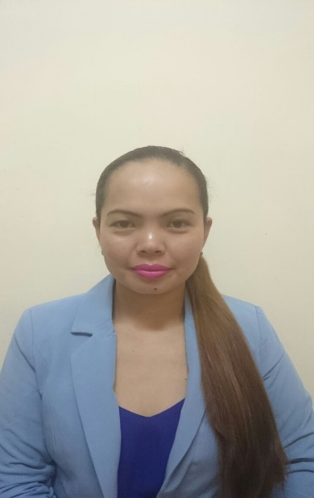
MARIVIC
MARIVIC.349230@2freemail.com

Objective:
To obtain a significant and challenging position wherein I will learn,
Excel my skills and abilities.

PERSONAL INFORMATION

Civil status: Single
Height: 5’0
Date of birth : August 07, 1986
Nationality : Filipino
Religion : Roman Catholic
Gender : Female
Age : 28 years old
Language : Visayan, Tagalog, English

EDUCATIONAL BACK GROUND:
TERTIARY: Bachelor of Public Administration major in Local Governance
Bukidnon State University, MalaybalayBukidnon City
(2004-2008)

SECONDARY: San Andres National High School
San Andres KadingilanBukidnon
(1999-2004)

PRIMARY:Kidalog Elementary School
San Andres KadingilanBukidnon
(1993-1999)

WORK EXPERIENCE:
MCDONALDS COMPANY
Crew trainer
From 2011 up to 2013
From July 1, 2013
Promoted as Crew trainer

JOB DESCRIPTION:
    - Train a new coming crew
    - Help the management team to deliver high quality of food,
Training and paper works etc.
    - Providing excellent customer service
    - Greeting customers at the door
    - Take order and do suggestive selling/sell up
    - Cashiering or Accepting payment from the customer.
    - Communicating customer orders to kitchen staff

TWIN PINES INCORPORATED
Marketing staff
From Sept.2008 to February 2011)
#4 Liwayway St., San Juan, Metro Manila

JOB DESCRIPTION:

    - In charge in selling the product
    - Performs any combination of duties to provide customer service
    - Answers questions and provides information to the customers
about the merchandise.
    - Keep records of sales and prepare inventory of stocks.
    - Making requisition
SKILLS:
    - Computer literate can speak English and tagalog.
    - Ability to work underpressure and meet the targets.
    - Excellence in customer service
    - Multi-tasking
    - Self-oriented
    - Can work with less supervision

SEMINARS&TRAININGS:
Office Clerk
Sangguniang Bayan Bayan Office
Municipality of kadingilan
(2007-2008)

Crew Trainer Class ( Dean’s List )
Emirates Food Company
Sharjah, UAE
January 6-7,2014

I hereby certify that above information is true and correct based on my knowledge and ability.

