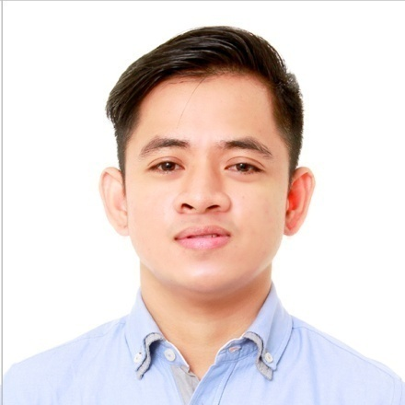
MARK
MARK..349253@2freemail.com
OBJECTIVE:
To be able to work in your establishment and to extend my knowledge an capabilities and become an excellent service provider.
EDUCATIONAL BACKGROUND:
MARINERS’ POLYTECHNIC COLLEGES FOUNDATION
Albay, Philippines
Bachelor of Science in Hotel and Restaurant Management
2011 – 2014
BICOL UNIVERSITY POLANGUI CAMPUS
Albay, Philippines
Bachelor of Science in Food and Technology
2009 – 2010
WORKING EXPERIENCE/TRAINING:
Assistant Restaurant Manager
Red Ribbon Bakeshop Inc.
Quezon City, Philippines
October 21, 2014 – January 31, 2017
- Responsible for providing quality customer service.
- Responsible for preparing the monthly / daily inventory of all store stocks.
- Responsible in overseeing transactions that are coming in and out of the store.
- Responsible in leading the team.
- Responsible in receiving and inspecting the newly delivered Cakes and Pastries.
- Responsible in encoding and overseeing all receiving items, transfer out products, transfer in products, wastages and ending inventory in a daily basis.
- Responsible in reporting to the Restaurant Manager any problems encountered in store.
- Responsible in doing all the necessary reports.
- Responsible in motivating and inspiring the team to achieve store productivity goals.
- Responsible in managing effectively the store operations, ensuring consistency and compliance.
- Responsible in being flexible in what might happen in store operations.

Kitchen Staff (Butchery Section)
Waterfront Manila Pavilion Hotel and Casino
Ermita Manila, Philippines
November 06 2013 – January 05, 2014
(500 hours on the job training)
- Responsible for preparing the needed meat products of the kitchen both Hot and Cold.
- Responsible for preparation of different slices needed in a Buffet Restaurant.
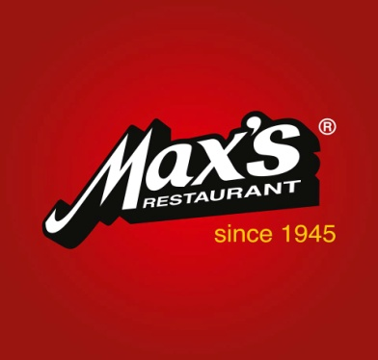
Dining Crew
Max’s Restaurant
Bicol,Philippines
July 24 – August 30, 2013,
(200 hours on the job training)
- Responsible for assisting guests with their needs.
- Responsible for taking the order of the guests.
- Responsible of taking in charge of the tables’ assignment.
- Responsible in bussing out soiled dishes.
- Responsible in attending the needs of the guests.
- Responsible in serving the food ordered by the guests.
AWARDS/ACHIEVEMENTS:
Proficiency in Food and Beverage Services
April 11, 2014
MPCF Legazpi City
Proficiency in Tourism Management
April 11, 2014
MPCF Legazpi City
Topnotcher Departmental Assessment of Academic Competency
April 11, 2014
MPCF Legazpi City
Food and Beverage Services NCII Holder
October 2012
PERSONAL INFORMATION:
Nationality: Filipino/Philippines
Civil Status: Single
Date of Birth: July 11, 1992
Passport Valid: until October 2019
Visa Status: Visit Visa

