Loiue.359266@2freemail.com

Good day!

I am Loiue, a graduate of Bachelor of Science in Radiologic Technology at Davao Doctors College, a Registered Radiologic Technologist and also a DHA passer/ Eligibility holder. I would like to express my intentions to be a part of your company as a Radiographer.

I was previously connected at Brokenshire Integrated Health Ministries, Inc. as a Radiologic Technologist (General Radiographer, CT-scan Technologist and Interventional Radiographer) for 3 years and have undergone training. I believe my education, skills, experiences and attitude fit your requirements.

With this cover letter, enclosed is my CV and contact number. I look forward to talk with you anytime. I hope my qualifications merit to your consideration.

Thank you for your time and consideration,

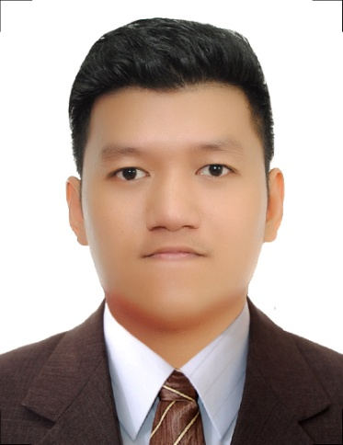
Loiue

PERSONAL INFORMATION

Age : 26 years old
Date of Birth : March 15, 1991
Gender : Male
Civil Status : Single
Nationality : Filipino

CORE QUALIFICATIONS

- I'm very hard working, easy to get along with, and can be easily trained with any skill that would require getting the job done
- Wide knowledge of handling procedure using different modality (CT-scan, C-arm, Fluoroscopy and X-ray machine)
- I'm also skilled in using computers and know some basic program, such as MS Word, Ms Excel and Ms Power point and others

PROFESSIONAL SUMMARY

Profession : Radiologic Technologist
Designation : CT-Scan Technologist, General Radiographer, Interventional Radiographer
Duration : May 28, 2014 – June 13, 2017
Company : Brokenshire Integrated Health Ministries Inc., (300 Bed capacity)
Company Industry : Healthcare/Medical
Location : Davao City, Philippines
Department : Radiology Department

MODALITITIES HANDLED

- SHIMADZU (Ceiling Mounted) Radiographic System Model UD 150L-40E with 630 mA tube capacity and ceiling tube support CH-200M device.
- SHIMADZU VISION EX-QUATRO X-ray machine with Flouroscopy, 650 mA tube capacity.
- SHIMADZU Portable X-ray Machine with 200 ma tube capacity.
- KODAK RP X-OMAT M7B Automatic Film Processor.
- General Electric BRIVO OEC 850 Mobile C-Arm X-ray
- PACS/RIS – Novarad System
- SIEMENS SOMATOM COMPUTED TOMOGRAPHY(128SLICES)
- KONIKA MINOLTA Digital Radiography cassette and loader

PROCEDURES HANDLED

- General Radiography with or without contrast
- General CT-scan (neck plain, neck with contrast cranial plain, cranial with contrast, stonogram, whole abdomen plain, whole abdomen with contrast, chest plain, chest with contrast, Guided biopsy, Calcium scoring, Angiogram)
- Assists in Interventional procedures with C-arm Guidance ( i.e.,Percutaneous Nephrolithotomy, Endoscopic Retrograde Cholangiopancreatography, Intraoperative Cholangiogram, Nephrostomy tube insertion)
- Assist in interventional procedures with X-ray machine Guidance (i.e., Retrograde Pyelography, T-tube Cholangiogram, HSG)
- Assist in Orthopedic related cases with C-arm or X-ray Portable Guidance (i.e Close reductions, Pinnings, Scoliosis Bracing, Femural Hip replacement, Intramedullary nailing of femoral bone)

EDUCATIONAL BACKGROUND

Tertiary:
Davao Doctors College 2013
Course : Bachelor of Science in Radiologic Technologist
Board rating average: 85.20% (Lic. # 0011998)
Education Field : Medical Science

SEMINARS/TRAINING

- Training in RIS/PACS – Brokenshire Integrated Health Ministries, Inc., Davao City Philippines (December 14, 2016)
- Basic Life Support Training: CPR for Health Care Provider - Philippine Red Cross (September 17, 2014) and (July 22, 2015) (September 19, 2016)
- THYROID & WOMEN’S SONOGRAPHY: Best Practices and Standards in Reporting – The Pinnacle Hotel and Suites, Davao City, Philippines (August 21,2016)
- Emerging basic practices in Vascular, Interventional and Breast Imaging – The Pinnacle Hotel Suites, Davao City, Philippines (August 23, 2015)
- 61st Foundation Anniversary and 46th Annual National Convention of the Philippine Association of Radiologic Technologist, Inc. – Teacher’s Camp, Baguio City (December 3-5,2015)

