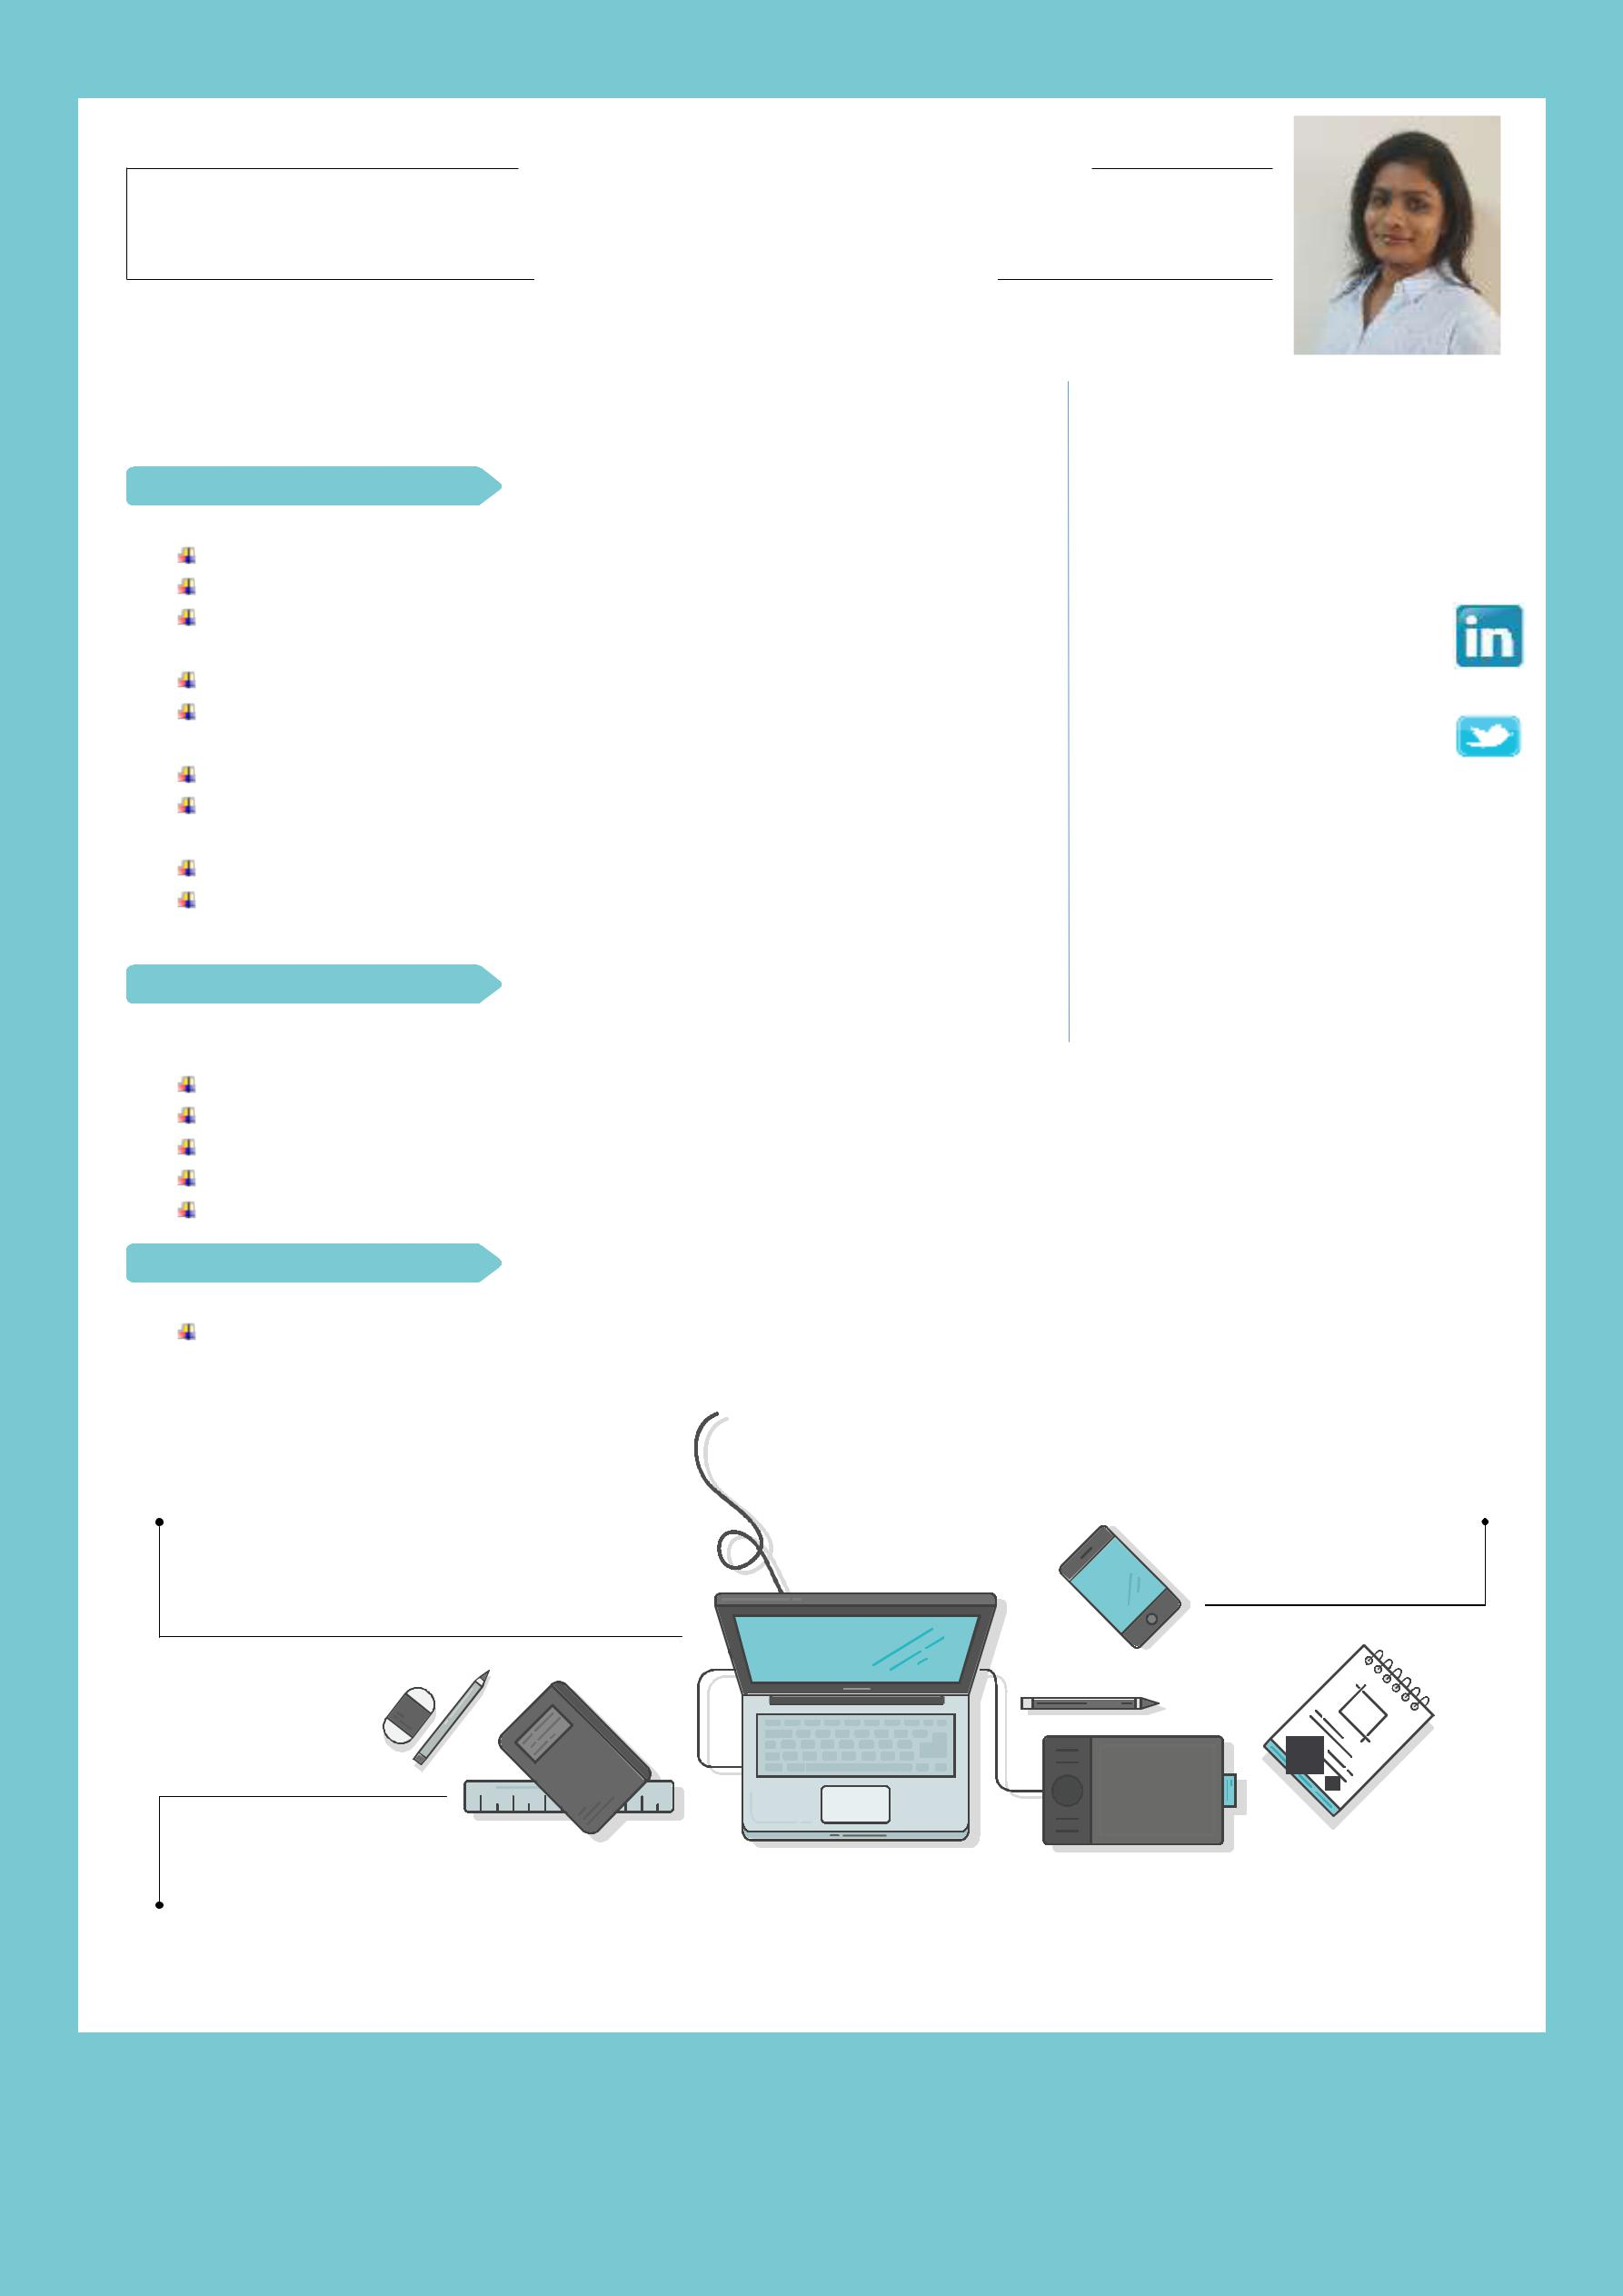
PRIYANKA

Excel and Grow across IT Landscape using Agile & Converged Technologies

EXPERIENCE

APRIL 2016 – NOV 2016

ASSOCIATE SOFTWARE ENGINEER / DENOVO DYNAMICS

Developed websites using SQL Server, Asp.net, C#, AJAX, MVC, JS Developed websites as per the provided requirement

Tested and validated work produced as part of the development process

Back end development and maintenance of websites using Asp.net Client briefing, SRS, BPR, Deployment using Agile & various other methodologies

Project coordination with the help of project manager Working towards & learning - Big Data & Analytics, Bespoke Development across platforms

Program, Software module testing etc

Achieved maximum client satisfaction on time delivery, and align to overall project timelines

OCT 2015 – MAR 2016

SOFTWARE CONSULTANT / EXTENDRUM TECHNOLOGIES,

(PORTLAND U.S.) AHMEDABAD

Created website in Asp.net MVC as per the client requirement Analyzed the requirement and prepared documentation Tested and validated the code

Prepared Crystal Reports, RDLC Reports and SSRS Reports Daily discussed with client about reports and status of project

DEC 2013 – SEP 2015

SOFTWARE ENGINEER /CHIRAG COMPUTERS

Developed modules and prepared technical documents of company project like Event Management System and Library Management System

Priyanka.349280@2freemail.com

EDUCATION

JULY 2010 – MAY 2013

MCA / BANASTHALI UNIVERSITY, TONK

,RAJASTHAN

Completed masters with 80%

Project - Ontology Alignment & Evaluation Using Graph using java

It provides a common conceptual basis for design a new matching system, or an elementary matcher using different technique & also using Word Net 3.0 as resource to find the accuracy in the generated RDF

HOBBIES SKILLS
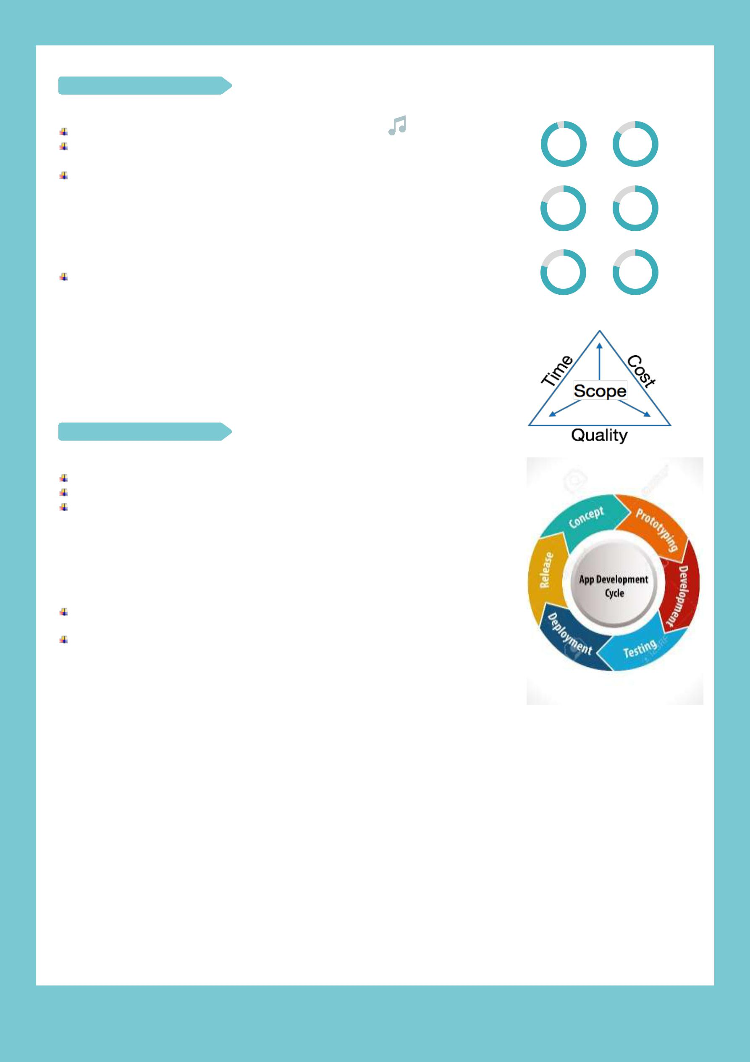

Music | Asp.Net | C#

MVC SQL

E-GAS SEVA (IBM’s The Great Mind ^{CSS} ^{HTML}
Challenge TGMC-2011) using HTML, JavaScript, Java, RAD (Rapid Application Development), WebSphere Server and DB2 database. Prepared a web based platform for consumers of gas cylinders and dealers, in order to facilitate them order no. of cylinders, registration and account for administrator

JULY 2007 – MAY 2010

BCA / MDS UNIVERSITY, AJMER,

RAJASTHAN

Completed BCA with 78.82%

Project- Smart Mind Quiz

Prepared a quiz application with different difficulty level in Visual Basic 6.0 and MS Access

ACADEMIC ACHIEVEMENT

Diploma in Computer Hardware and

Maintenance (87%)

IBM Certified Associate System

Administrator Lotus Notes and Domino 8

TECHNICAL INTEREST

Highly interested to learn new technologies around BI, Analytics, M2M, Agile PM, SOA, SDLC, Ent. Bus/Web layer &Integrations etc.

Follow industry leaders, and Benchmarks like

Gartner’s, IDC & Forrester, CMMI etc.

PERSONAL DETAILS

Date of birth | : 13th July 1989
Nationality | : Indian
Status | : Married

“Activity gets you busy. But productivity gets you free”

2017 | Dubai UAE

LANGUAGES

English, Hindi, Gujrati

