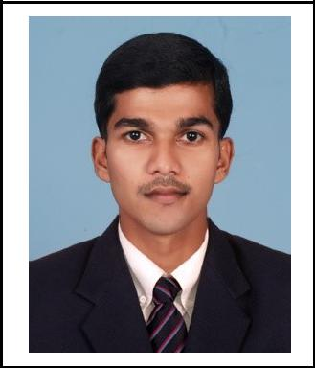
TIJO

Tijo.349290@2freemail.com

CAREER GOAL

To obtain a challenging and responsible position in a reputed organization, where I can learn and mould my career while contributing to the success of the organization through my skills and hard work.

PROFESSIONAL EXPERIENCE

LUPIN LIMITED, INDIA
Marketing executive (January 2015 – January 2017)

Responsibilities:
- Accomplish the sales target.

- Maintaining good relationship with customers.

- Distribution of products on time.

- Ensuring payments are not exceeding credit limit.

- Updating information regarding the products and deliver it to the customer.

- Preparation of weekly report on customer meeting.

- Preparations of brand wise monthly sales report in Microsoft excel.

- Preparing PowerPoint presentation on the basis of quarterly sales analysis for presenting in review meeting.
- Analyzing the competitor’s activity and products.

- Proper distribution of promotional materials.

CARRIER ACHIEVMENTS

- Developed various sales approaches by analyzing data of new products.

- Successfully promoted and sold products and medical devices manufactured by lupin ltd.

- Achieved sales target in the financial year 2015 - 2016 and 2016 - 2017 till January.

ADITYA BIRLA GROUP
Assistant store manager (May 2012 – December 2014)

Responsibilities:
- Grievance handling

- Supervising the monthly stock taking

- Day today accounting and allied activity

- Delivery note preparation.

- Maintenance of stock registers in FIFO method.

- Assisting internal and external stock audit.

- Stock reconciliation.

- Interdepartmental stock transfer monitoring.

1 | 2

EDUCATION

- MBA in Finance and Marketing, Secured 60% Bharathiar University, Coimbatore April 2012

- B.com(Computer computer application) Kerala university, alappuzha April 2008

PROJECT
Company | : Berger paints
Topic | : analyzing the supply and presence of Berger products
 | : SWOT analysis

SKILLS
Software: MS office – Excel, PowerPoint, Word, Windows 8, 7, XP

PERSONALSTRENGH

- Self motivated

- Team player

- Good communication skill

- Energetic

- Enthusiastic

- Well accounting knowledge

PERSONAL | DETAILS
Sex |  |  | : Male
Nationality |  |  | : Indian
Visa Type & Expiry |  |  | : Visit
Driving License |  |  | : Nil
Marital Status |  |  | : Single
Blood Group |  |  | : O+ve
Religion & Caste |  |  | : Christian, Latin catholic
Languages Known |  |  | : English, Malayalam, Hindi and Tamil

REFERENCES: -

Reference will be provided on request

DECLARATION

I hereby declare that all the above mentioned details are true and correct to best of my knowledge and belief.

Place: Dubai

TIJO

2 | 2

