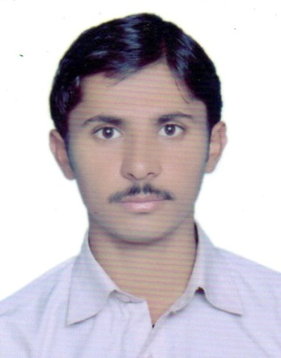

Email: aqeel.349314@2freemail.com

Visa Status: Visit Visa (UAE)

Aqeel

CAREEROBJECTIVE:

To secure achallengingpositionofAssociate
Engineerformutualbenefitifgivenachanceinyourreputedorganizationto
Facilitate professionalgrowth on myqualification and experience white
Embracing new methodologies& strategies toremaincompetitiveinthe market.

CAREERHISTORY:

Create, improve and protect the environment in which we live.
They plan, design and oversee construction and maintenance of building structures and
Facilities, such as roads,railways,airports,bridges,harbors,dams,irrigation projects,
Power plants, water and sewerage systems

1. ProjectName:Chepplet Factory (PVT)

Experience: One & Half Year in HCS & Engineers as a Site Supervisor

Duration: Aug 2015 to Jan 2017

2. ProjectName: Sialkot International AirPort Run Way Safety Area

Experience:9 Months in Bhullar International Contractor (LTD) as a Surveyor

Duration: Sept 2014 to June 2015

3. ProjectName: Sialkot International AirPort Emergency Road

Experience:11 Months in Bhullar International Contractor (LTD) as a Surveyor

Duration: Aug 2013 to June 2014

4. ProjectName: A.T.S Factory Oil Heater Hall

Experience:10 Months in Ittfaq Group of Construction as a Site Supervisor

Duration: Sept 2012 to June 2013

TotalExperience

Morethan4 yearExperience in Civilfield

PERSONALHISTORY:

DateofBirth | : 14-08-1995
Nationality | : | Pakistani
Domicile | : | Sialkot(Punjab)
Religion | : | Islam
Status | : | Single

EDUCATIONALHISTORY:

Certificate | NameOfInstitute | Passing | Division |  | Session
/Degree | (Board/University) | Year
D.A.E(Civil) | PBTE(Lhr) | 2015 | 1st | 2012-2015
Matric | BiseGujranwala | 2010 | 1St | 2010

TECHNICALSKILLS:

GeneralSkils/Commandontheunder

Mentioned:

- DiplomaInAutoCAD(2D&3D)

LANGUAGES:

Canread, write, understand &speak,English,Urdu

HOBBIES:

ReadingBooks, NetBrowsing,

